Kid’s Corner Week 34

Bible Verse: Now Israel loved Joseph more than all his children, because he was the son of his old age. Also he made him a tunic of many colors. Genesis 37:3

The Christmas season is over so we will again be concentrating on the Old Testament stories

that color the Bible with life lessons. The story for today is again from the first book of the Bible

called Genesis. Remember before Thanksgiving our last Old Testament story was about Jacob

and Esau. Now jump forward many years and Jacob also known as Israel had been very blessed

with 12 sons. One of the sons, Joseph, the youngest was Jacob’s favorite. Jacob gave Joseph a

gift of a coat or tunic of many colors. Joseph was very happy and he knew that he was favored

by Jacob. Joseph’s brothers were very jealous that Joseph was given that special coat and they

weren’t given anything.

Have you ever been given something that your brothers or sisters weren’t given? Maybe your

mom or dad took you somewhere and your siblings didn’t get to go. They may have been

jealous of you. Hopefully if this happened to you, your parent or relative also gave a gift or

spent time with your brother or sister. Parents love all their children and all people are special

in God’s eyes. We are all “wonderfully made” by God. We are all designed by God too.

Joseph was a special son to Jacob/Israel. God had a special plan for Joseph. Joseph was loved

by God and you are too!

Pick up your Anglican Prayer Book today and read God’s Word!!

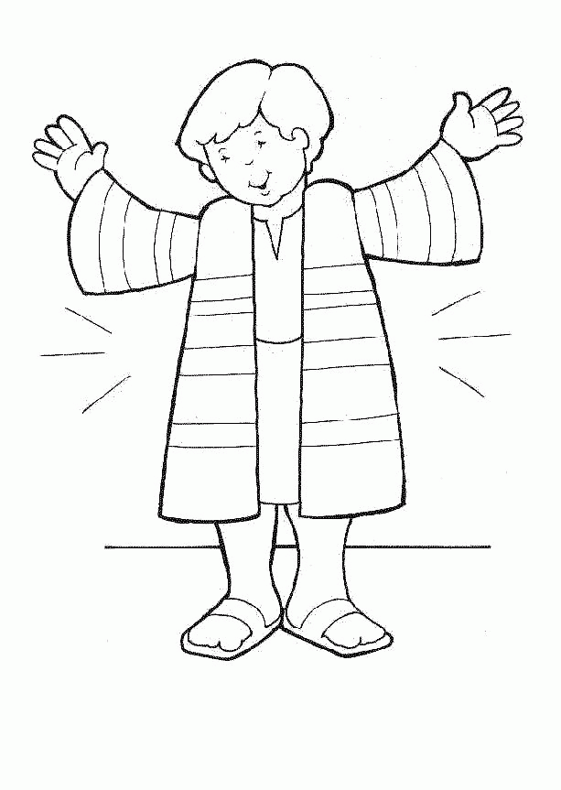
JOSEPH
https://coloringhome.com/josephs-coat-of-many-colors-coloring-page

