Kid’s Corner Week 33

Bible Verse: After Jesus was born in Bethlehem in Judea, during the time of King Herod, Magi^{[a]} from the east came to Jerusalem and asked, “Where is the one who has been born king of the Jews? We saw his star when it rose and have come to worship him.” Matthew 2: 1-2 (NIV)

Hi everyone!!! Did you see the bright star in the sky in the last couple of weeks?? It has been

seen by many and pictures have been taken. Father John and I saw it on the way to church in

the wee hours of the morning a couple weeks ago. It was so big and bright. It hasn’t been seen

for about 800 years. That’s a long, long time ago!!! It was the only star in the sky the morning

we saw it It made me think about what we are celebrating today. We are remembering the

Three Wise Men that visited Jesus long ago. They had traveled many miles to find him and the

whole time they were following the bright star in the sky. The Three Magi, as some call them

brought gifts for the babe. The gifts were what you would give to a king: gold, frankincense and

myrrh. After all the Magi told Herod that they were trying to find the king of the Jews. King

Herod, who was the present king of the Jews asked his chief priests and teacher about the

Messiah and they told him that the child was to be born in Bethlehem so off the Magi went to

Bethlehem. The three kings knelt down and worshipped Jesus just like the Shepherds. When it

was time for them to travel back to their home they were told not to go back to King Herod but

to go another route. So what gift can you give to Jesus today? How about loving him with your

heart, soul, mind and strength? Jesus wants to be your SAVIOR. He wants to SAVE you from

your sins so that you can go to heaven and live with him there. Won’t you say YES??

Help the Three Wise Men to find Jesus

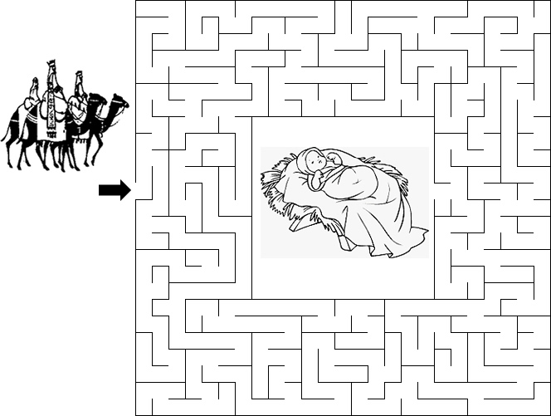

https://sermons4kids.com/wise_men_maze.htm

