Kid’s Corner Week 32
Bible Verse: When the time came for the purification rites required by the Law of Moses, Joseph and Mary took him to Jerusalem to present him to the Lord (as it is written in the Law of the Lord, “Every firstborn male is to be consecrated to the Lord”^{[b]}), and to offer a sacrifice in keeping with what is said in the Law of the Lord: “a pair of doves or two young pigeons.” Luke 2:22-24
It was a Jewish custom for a baby to be presented at the temple after he was born. At the

temple the baby would be named and in this case we know the baby was to be called JESUS.

This was the name that the two angels had told Mary and Joseph that the babe would be

named. So Joseph, Mary and Baby Jesus traveled to the temple in Jerusalem. There they met

two very old people. One was named Simeon and one was named Anna. Simeon is described

as a” righteous and devout” man. Simeon was very old. He had been waiting to meet the

Savior of the World in the temple. He took Jesus in his arms and blessed him. Then Mary and

Joseph met another very old person, a woman named Anna. She was a prophet, meaning she

could deliver messages or teachings from God. It is said in Luke 2 that she lived at the

Jerusalem temple, fasting and praying ever since her husband died. Anna went up to Joseph

and Mary because she knew that Jesus was going to be a Savior to Jerusalem. She thanked God

for his birth. She knew that Jesus was the Messiah! Jesus was not just an ordinary baby. Jesus

is God that came to the earth as a human to be the Savior of the World. Let us honor and

praise Him every day in prayer and worship!!!
WATCH THIS MUSIC VIDEO TO SEE SIMEON BLESS BABY JESUS:
https://www.youtube.com/watch?v=Z4nvVw8z6K8

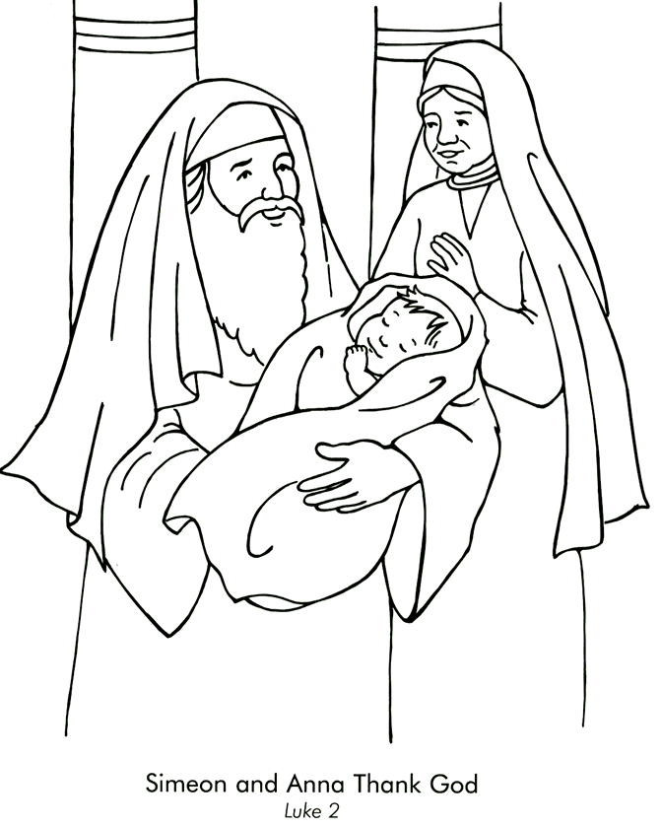

https://sermons4kids.com/simeon-anna-colorpg.htm

