Kid’s Corner Week 31

Bible Verse: And there were in the same country shepherds abiding in the field, keeping watch over their flock by night. And, lo, the angel of the Lord came upon them, and the glory of the Lord shone round about them: and they were sore afraid. And the angel said unto them, Fear not: for, behold, I bring you good tidings of great joy, which shall be to all people. For unto you is born this day in the city of David a Savior, which is Christ the Lord.
I certainly hope everyone had a joyous Merry Christmas. Here we are the Sunday after the

wonderful day but we skipped a part from that Christmas story that is very important. You see there

were some shepherds in the area where Jesus was born. They were told of Jesus birth by an

angel. The angels were very busy when it came to Jesus, our savior. Remember an angel told

Mary she was going to have a baby and then an angel spoke to Joseph in a dream and told him

that the baby that Mary was to have was given to her by the Holy Spirit. Now on that Christmas

night an angel again told the shepherds the good news of Jesus’ birth. The shepherds were

afraid at first but the angel told them not to be afraid because a savior was being born that

night. Then many angels came and told the shepherds to go see this newborn king. When the

angels left, the shepherds all agreed that they should go and see Jesus, wrapped in swaddling

clothes and lying in a manger in the city of Bethlehem. After the shepherds left

Bethlehem they couldn’t keep this news to themselves. They told EVERYONE about Jesus!!!!!!

This is what God wants you to do…….be like the shepherds and tell everyone about your savior

Jesus Christ. Tell everyone how Jesus came to this earth as a tiny baby for you and I. And

how He died on the cross so you could go to heaven and live with Him there.

Listen to this favorite Christmas carol: What Child is This.
https://www.youtube.com/watch?v=D9PXYGAkrPE

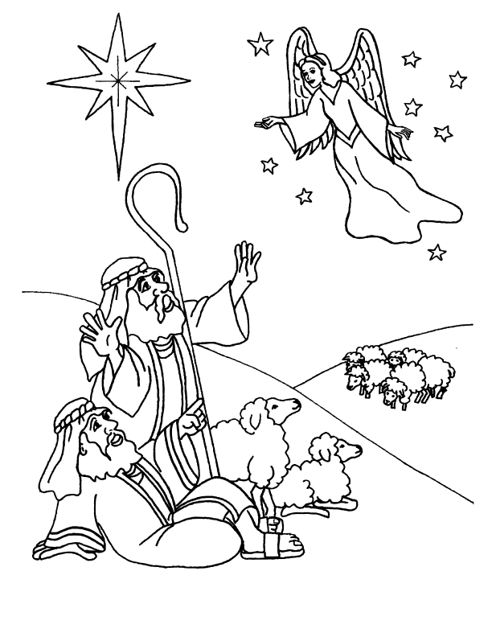

Copyright © 2004, BibleWise. All Rights Reserved. Coloring page by Susan Berger.

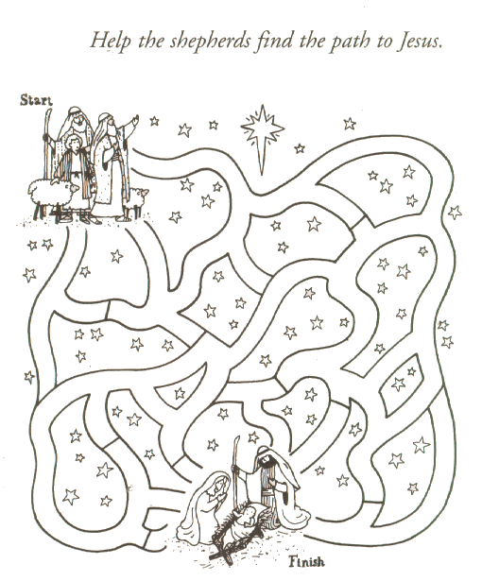
http://www.getcoloringpages.com/coloring/49380

