Kid’s Corner Week 29

Bible Verse: But after he had considered this, an angel of the Lord appeared to him in a dream and said, “Joseph son of David, do not be afraid to take Mary home as your wife, because what is conceived in her is from the Holy Spirit. She will give birth to a son, and you are to give him the name Jesus,^{[c]} because he will save his people from their sins.” Matthew 1:20-21

Who remembers the name of the angel that appeared to young Mary in our previous story and

told her she would be the mother of the Savior of the world?? He’s a very famous……anyone

remember???? Gabriel, the Angel Gabriel was his name. Now this week’s story is also about an

angel too but he’s unnamed and this angel appears to Joseph in a dream, not in person. This

angel tells Joseph that the baby that Mary is carrying should be named JESUS. So both angel’s,

Gabriel and the unnamed one tell Mary and Joseph to name the baby Jesus. If you look up the

meaning of that name it means “to deliver; to rescue.”. How very perfect of a name for a

perfect little baby. For we know that this was the very reason that God wanted the baby Jesus

to be born after all. God knew that His Son, Jesus would be the “Rescuer of the World.” The

angel said in the dream to Joseph that this little baby would “save his people from their sins.”

And isn’t that what a rescuer does. A rescuer saves people. So when you remember this part

of the Christmas story remember that most important message that Jesus came to be the

Savior of the World.

Watch this music video about the Deliverer of the World by Rich Mullins
https://www.youtube.com/watch?v=K8-NxI_IWd0

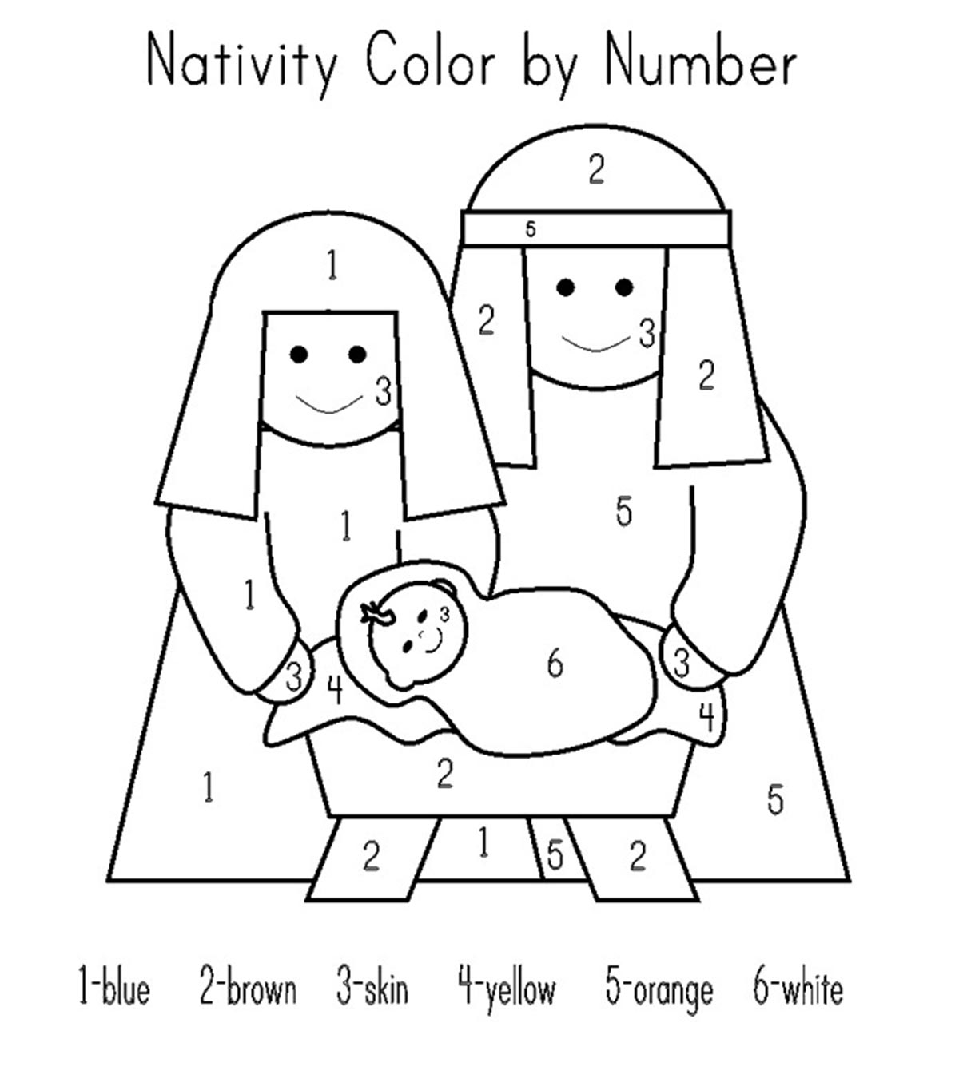
https://www.momjunction.com/articles/nativity-coloring-pages_00120175/

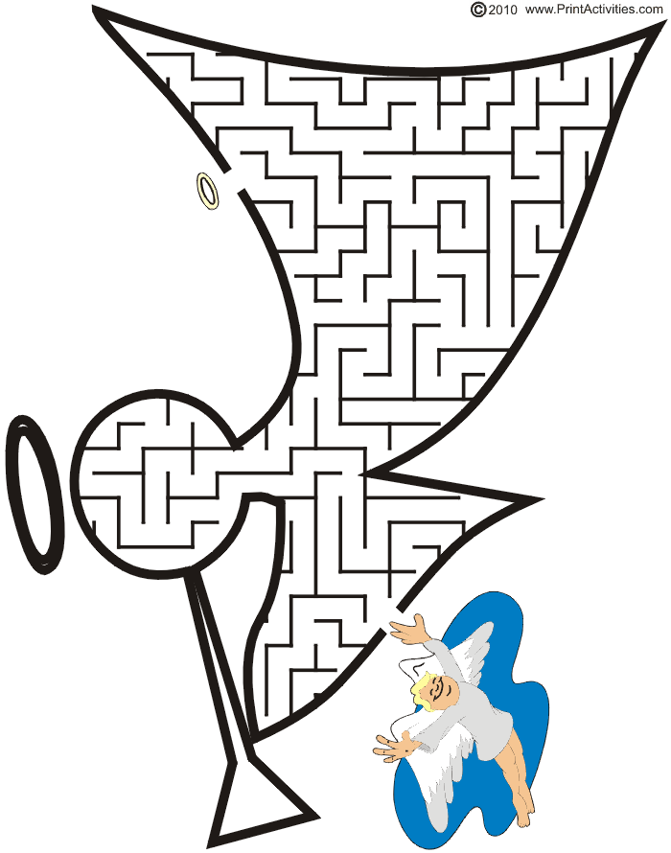

https://www.pinterest.com/pin/118219558939523462/

