Kid’s Corner Week 28

Bible Verse: But the angel said to her, “Do not be afraid, Mary; you have found favor with God. You will conceive and give birth to a son, and you are to call him Jesus. He will be great and will be called the Son of the Most High. The Lord God will give him the throne of his father David, and he will reign over Jacob’s descendants forever; his kingdom will never end.” Luke 1:28-33

God had big plans for a young woman named Mary. The plans were so big that God sent an angel named Gabriel to deliver them. Our story today which marks the first Sunday in Advent comes from the book of the Bible named Luke. The Bible tells of Mary who loved God. Mary was excited because she was going to marry a man named Joseph. Then one day God sent the angel Gabriel to give Mary a special message. Mary was afraid for she had never seen an angel before. Gabriel told Mary that God had a special job for her. He told her that she would have a baby and she was to name the baby Jesus. Then Gabriel told Mary that the baby was the Son of God!! Mary asked how will this happen as she wasn’t even married yet? Gabriel said “God will be with you, God can do anything.” Mary replied that she loved God so she would do whatever God asks. Then the angel Gabriel left.
This was certainly an important moment in the Bible. This is where the New Testament starts. This is also where the new church year begins with the first Sunday in Advent. Advent means, to come or arrival referring to the birth of Jesus Christ. The dictionary meaning is: the arrival of a notable person, thing, or event. This is definitely evident in that Jesus is notable and we will be celebrating his birth in just four short weeks. There are four Sundays in Advent ending in the birth of Jesus on Christmas morning. We are just beginning the countdown to Christmas. It’s so exciting!! The Christmas story is one of the most loved stories in the Bible. It is all about God’s special plan to save the world. His special plan was Jesus Christ the Son of God. He has a special plan for each and every one of us too just as he had for Mary. We will be talking about God’s plan for the next few weeks. Stay tuned, listen and learn!!!!!
Listen to this very special Advent song:
https://www.youtube.com/watch?v=SkvYR4BcHYc

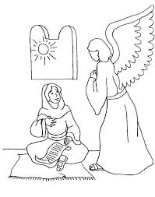

https://www.bmoretattoo.com/q9j1558ls/xF15605oU/

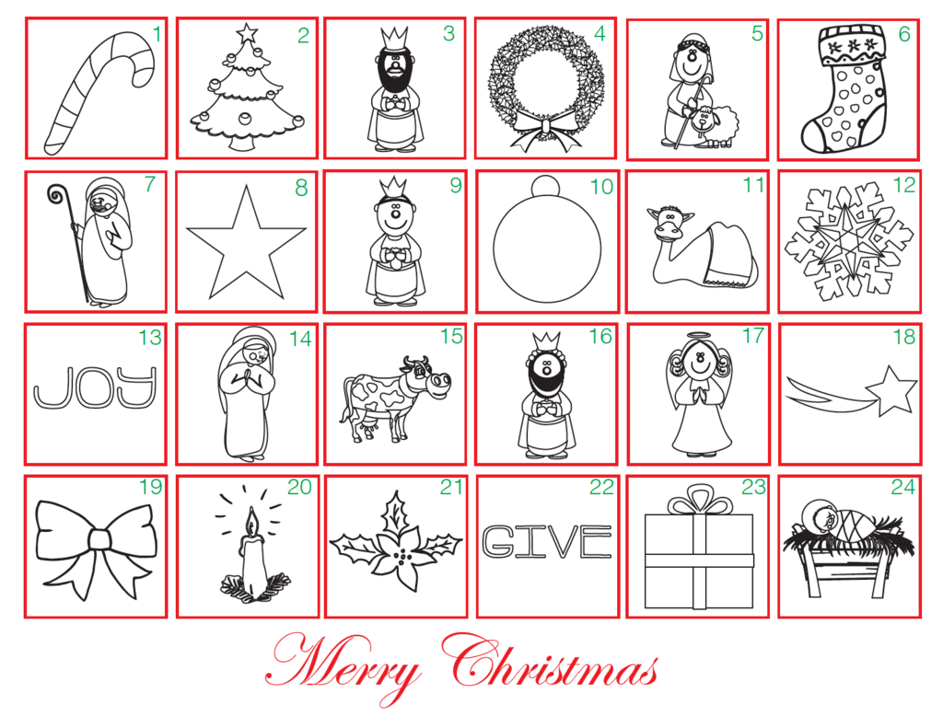
https://www.childrens-ministry-deals.com/products/advent-coloring-calendar

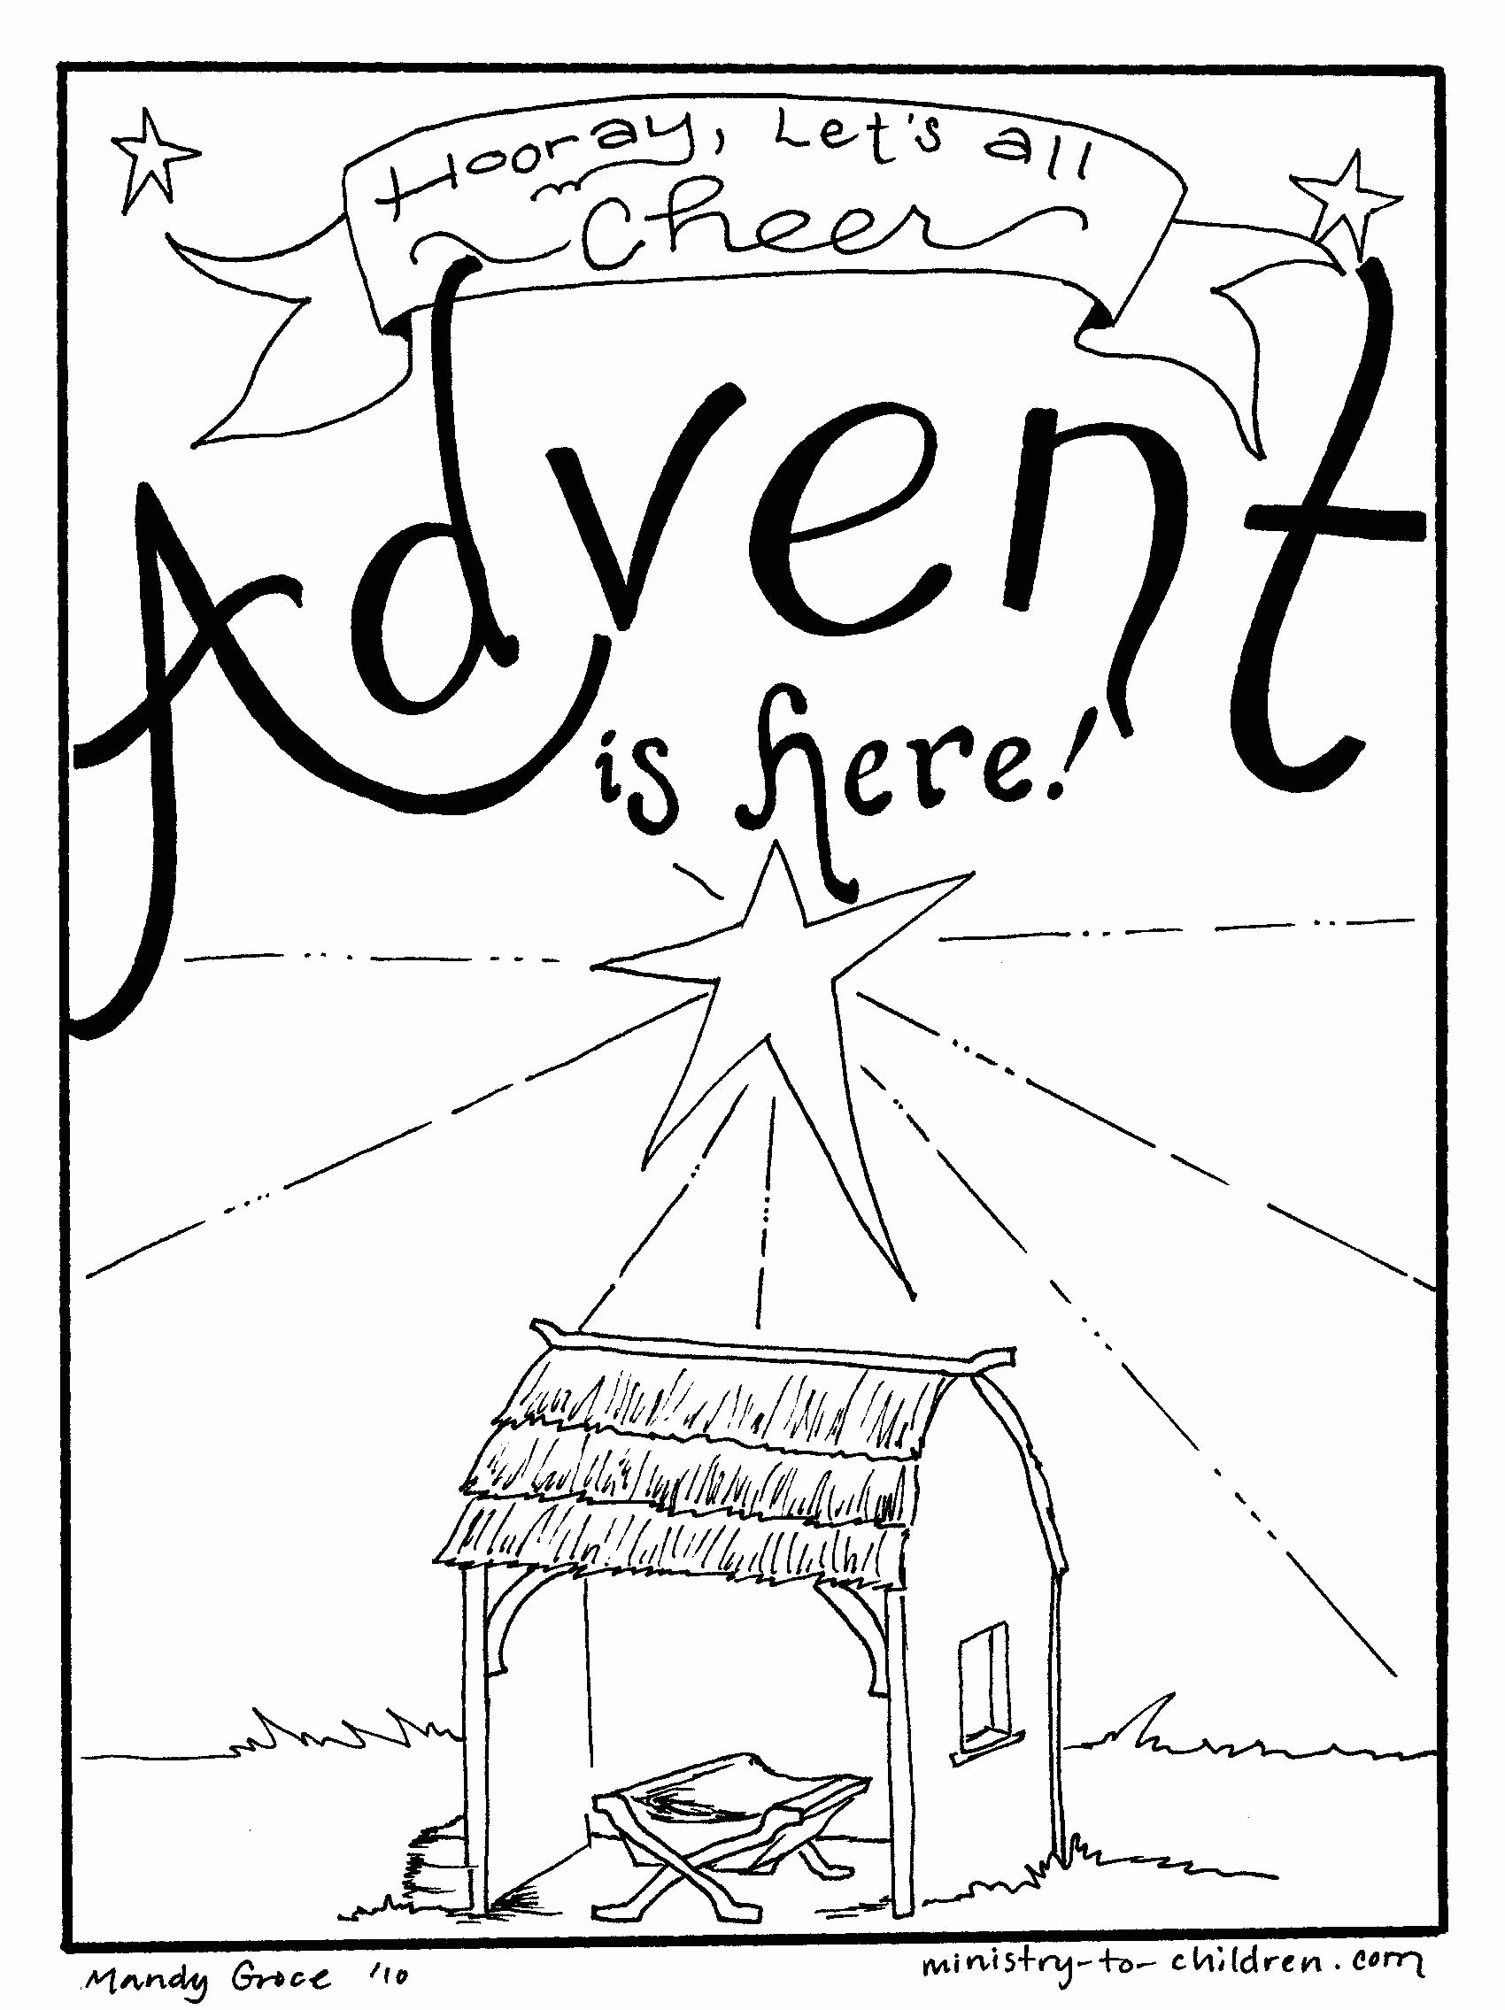

Teen Talk
Collect: ALMIGHTY God, give us grace that we may cast away the works of darkness, and put upon us the armour of light, now in the time of this mortal life, in which thy Son Jesus Christ came to visit us in great humility; that in the last day, when he shall come again in his glorious majesty to judge both the quick and [the]* dead, we may rise to the life immortal, through him who liveth and reigneth with thee and the Holy Ghost, now and ever. Amen.
Today we start to celebrate the season of Advent. The first Sunday in Advent is really important
for two reasons; one because it is the beginning of the Christian calendar and two because we
are counting down to the birth of Jesus Christ, the Savior of the World who came into the world
some 2000 years ago. He promised to return in all His glory one day. Advent is the time to
celebrate His light in the darkness of the world. The collect above will be said for the next four
Sundays. It emphasizes Jesus’ birth and promise. The first Sunday in Advent we light the purple
candle of HOPE in the Advent wreath. Hope is a light shining in a dark place and that light is
Jesus. As we light this first candle we celebrate the Hope we have in Jesus. What is this Hope?
The definition in Dictionary.com is 1. A feeling of expectation and desire for a certain thing to
happen and 2. A feeling of trust. The feeling of expectation would be for eternal life in heaven
with Jesus. And a feeling of trust would be our faith in Christ that things will never decay or
waste away if we just believe in Jesus. As we go through this troubled time in our world with
the Covid 19 pandemic let us be reminded of the hope that lies in Jesus with this Psalm 71:5 For
you, O Lord, are my hope, my trust, O Lord, from my youth. Remember these words as we
start the Advent season.
Watch this music video: Hope Has a Name-Kristian Stanfill
https://www.pinterest.com/pin/307722587024548122/

https://www.pinterest.com/pin/307722587024548122/

