Kid’s Corner Week 27

- Bible Verse: "Give thanks to the Lord, for he is good; his love endures forever." 1 Chronicles 16:34
Wow!!!! This week we will be celebrating Thanksgiving. I can’t wait for turkey, stuffing and

pumpkin pie. How about you? What’s your favorite food for Thanksgiving?? But what does

Jesus want us to remember about Thanksgiving? This story might help you understand the real

meaning. The Bible tells us about some men who were sick. No one could go near them. The

10 sick men left their homes and families. They lived by themselves outside the town. The men

were very sad. One day, Jesus was walking down near the road where the men lived. The 10

sick men saw Jesus walking. These men knew that Jesus could help them. They called out to

Jesus, “Jesus, please help us!” Jesus cared about the men. He knew how sick and lonely they

were. “Go show yourselves to the priests,” He told them. The priests worked in the temple like

Father Guy and Father John work at St. Stephens. If the priests said the men were well, they

could live with their families again. The 10 men hurried toward the town and then they saw

something amazing!! They were healed!! They ran to town as fast as they could. But one man

stopped running. He went back to Jesus. “Thank you, Jesus,” the man said. “Thank you for

making me well and caring for me. Praise God!”

Jesus cared for the 10 men. He made them all well. Jesus was happy that one remembered to

thank Him.

Take time today and every day to thank God for all that you have!!
Happy Thanksgiving!!

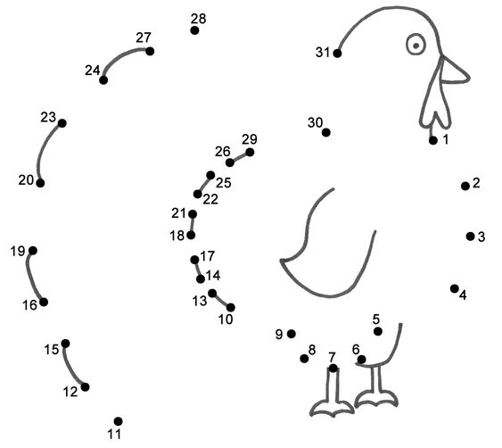

https://www.bigactivities.com/ctd/thanksgiving/turkeys/turkey.php

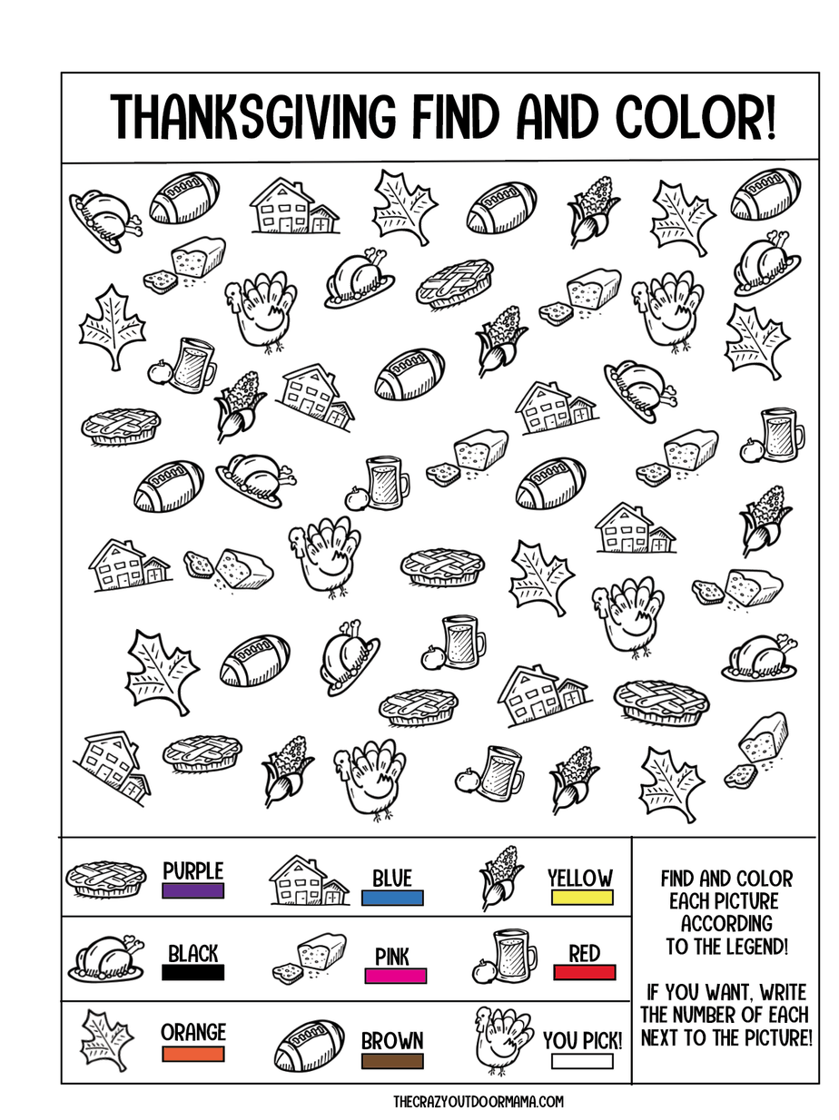

Scavenger Hunt

Teen Talk

Bible Verse: Enter his gates with thanksgiving and his courts with praise; give thanks to him and praise his name. Psalm 100:4 NIV
Thanksgiving is this Thursday. What does that day make you of? I think of delicious turkey, stuffing, cranberry sauce and Pilgrims. We always equate first Thanksgiving in 1621 as a huge feast with turkey and all the trimmings that the Pilgrims ate with the Native Americans. History.com reports that according to William Bradford’s account called “On Plymouth Plantation, relates that “there was great store of wild turkeys, of which they took many, besides venison, etc.” Some accounts say wild fowl like duck and geese was served instead of turkey. It is also reported that with the help of their Native American friends the Pilgrim’s feasted on, “corn, beans, lettuce, spinach, cabbage, carrots and perhaps peas,” as well as “blueberries, plums, grapes, gooseberries, raspberries, and, of course cranberries.” One thing we don’t usually eat for Thanksgiving was present at the First Thanksgiving and that was seafood. The Pilgrims ate mussels, lobster bass, clams and oysters. If you look at paintings depicting this feast like the one below you see just what I described above:

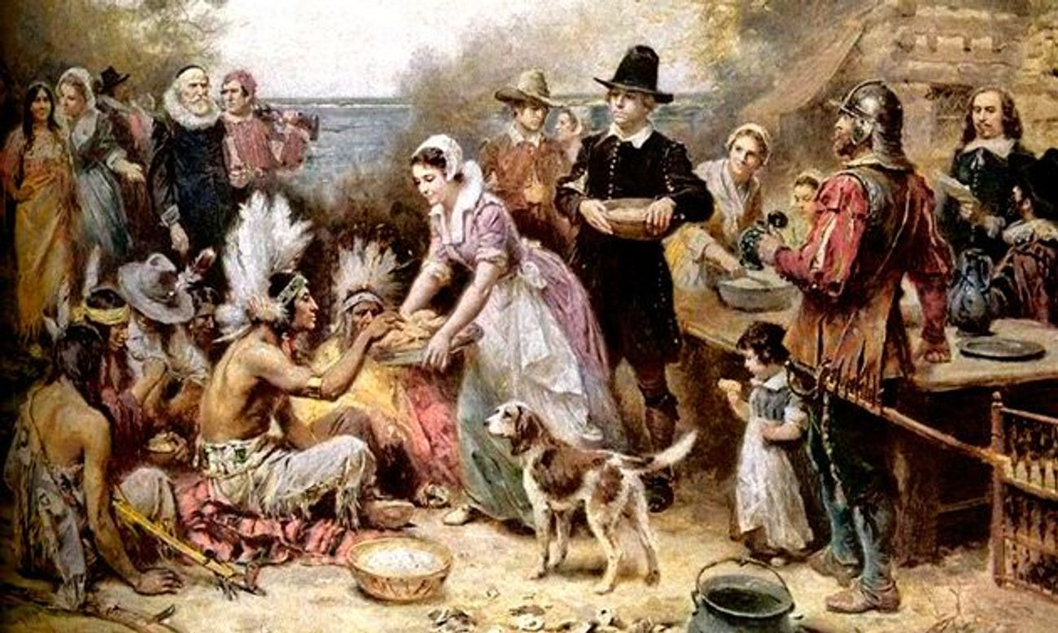
The Pilgrims and the Wampanoag people are sharing a feast that
lasted for three days. The Native Americans brought the venison.

The 100 Pilgrims that were aboard the Mayflower in 1620, were seeking religious freedom in the New World. They landed at Cape Cod, Massachusetts and traveled to Plymouth Harbor where they built the first settlement. Life was difficult and poor nutrition and inadequate housing killed many the first year but the ones that survived came together to celebrate the plentiful harvest. According to History.com., Edward Winslow, a Pilgrim chronicler wrote of the First Thanksgiving and of the Native Americans, “And although it be not always plentiful, as it was at this time with us, yet by the goodness of God, we are so far from want, that we often wish you partakers of our plenty.” The Pilgrims were thankful for their survival in the harsh New World, and wanted to share their good fortune. As we relax in our homes this Thanksgiving of 2020, let us be grateful to God for our many blessings that He has bestowed upon us. Amen.

Grateful Video: Elevation Worship:
https://www.youtube.com/watch?v=oh2goMABFPc
And this video: There’s Nothing That Our God Can’t Do From Passion 2020
https://www.youtube.com/watch?v=5MChgCghLJg

