Kid’s Corner Week 25

Bible Verse: The boys grew up, and Esau became a skillful hunter, a man of the open country, while Jacob was content to stay at home among the tents. Genesis 25:27

Today we’re going to examine how God made each of us wonderfully different. If you

remember last week we talked about the birth of Isaac. God told Abraham that he would have

a son even though Abraham was 100 and Sarah, his wife was 90 at the time Isaac was born.

God made a promise that Abraham would be the father of many generations, as many as the

stars in the sky. Abraham couldn’t count the stars in the sky but God had promised that he

would have that many descendants. Isaac grew up and married Rebekah. Isaac and Rebekah

wanted to have a baby too so they prayed to God to give them a child. God answered their

prayer in a big way----He gave them twin boys, Esau and Jacob. Esau was born first and had red

hair on his head and even his skin was reddish. Jacob came next and he hardly had any hair. As

the verse above says, “Esau was a skilled hunter and Jacob was content to stay at home among

the tents.” They were wonderfully different. But one thing was the same for both of

them…..God made Esau and God made Jacob. Just as Esau and Jacob were different, each of us

is different. We look different and we like different things. Even though we are different one

thing is the same for each of us: God made us. He made each of us special.

Read your Bible & Anglican Prayer Book Every Day!

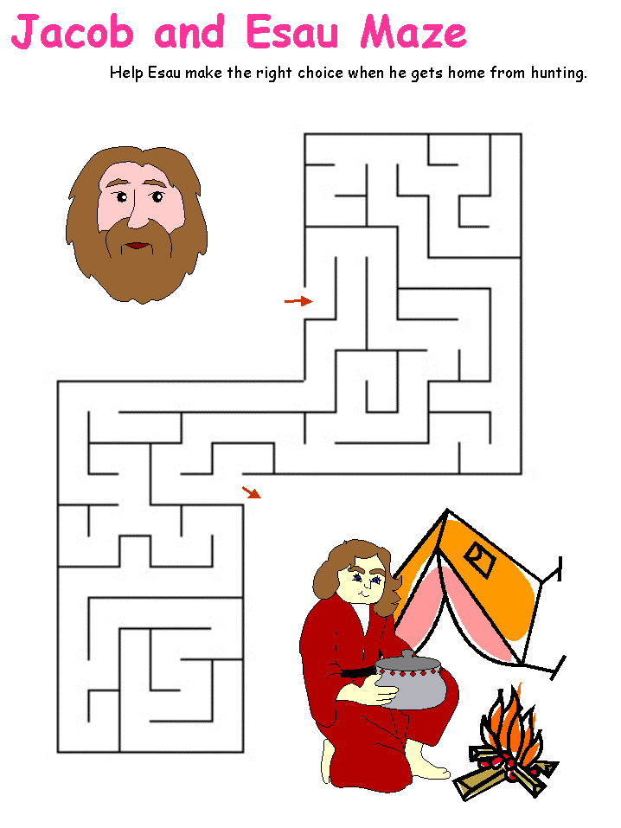

https://www.dltk-kids.com/bible/old_testament/jacob_and_esau-worksheets.htm
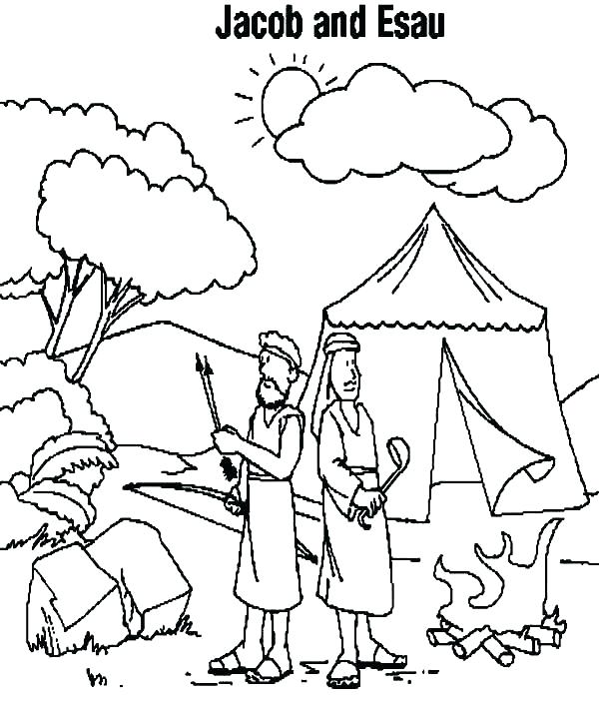

https://coloringhome.com/jacob-esau-coloring-pages

Teen Talk
Bible Verse: “I praise you because I am fearfully and wonderfully made; your works are wonderful, I know that full well.” Psalm 139:14 (NIV)

Have you ever met twins before? Most of the time the twins you meet are identical; they look

exactly alike. Sometimes however the twins are fraternal; they look totally different. My

grandsons, Joey and Ben are fraternal twins and if you have ever met them at Sunday School

you would know that they don’t look anything alike and have totally different personality’s too.

This was the case with Esau and Jacob when they were born to Rebekah and Isaac. Esau’s skin

was red and he had a hairy body while Jacob came out grasping Esau’s heel. The Bible doesn’t

really tell us how Jacob looked but it does reveal that the two brothers were vastly different in

interests. Esau was a “skillful hunter,” while Jacob “ was content to stay at home among the

tents.” Isaac loved Esau best and Rebekah loved Jacob best. As the Bible verse says, these twins

were “fearfully and wonderfully made. God made them and us by his own hands. But guess

what? None of us is perfect. God loves us anyway though, so much that God sent his only son

to die for us so that he could forgive our sins. No matter how bad we mess up God still loves

us. We will learn in next week’s lesson that these two brothers were not perfect either but God

had a plan for them and he has a plan for us. God knows what we are going to do or say before

we even act or speak. We live in a world of sin and each of us invariably will sin but God will

love us through every sin. He will always forgive us if we are truly sorry and ask for forgiveness.

God loves us in spite of all our mistakes. He wants us to freely commit ourselves to him that’s

why he gave us free will. We are “fearfully and wonderfully made,” (Gen 139:14) by God. He

wants us to do better. He gave us the Bible, our parents and our church leaders to teach us

right from wrong. He gave us the Holy Spirit to guide us after his son Jesus ascended to heaven.

Because we are human, God knows we are not perfect. We’re going to mess up, and when we

do he still loves us through it all. No matter what you’ve done or will do God still loves you!!

Watch this video by We Are Messenger-Image of God:
https://www.youtube.com/watch?v=8yV0pu60Uqs

And this video by Mandisa and Jon Reddick-You Keep Hope Alive:
https://www.youtube.com/watch?v=Xv1NJzpjT4Q

