Kid’s Corner Week 24
Bible Verse: “Look up at the sky and count the stars—if indeed you can count them.” Then he said to him, “So shall your offspring^{[d]} be.”

Have you ever gone camping in the woods far away from the city and looked up at the night

sky?? If you have, you may have seen hundreds of bright shining stars in the sky. Remember

from last week’s lesson that God led Abraham and Sarah to new home far away and God told

Abraham that he would be the father of a great nation. But Abraham and Sarah thought that

they were too old to have a child. Well God also made that promise to Abraham and Sarah that

they would have a son even though they were very, very old. Abraham was one hundred and

Sarah was ninety. God told Abraham to go outside the tent and look up to the sky and try to

count the stars . That’s how many children, grandchildren, great grandchildren, great, great

grandchildren that Abraham would have. There’s no way that Abraham could possibly count

those shiny stars. But God had made a promise to Abraham that he and Sarah would have a

baby. Isaac was born soon after. God’s promise came true. You can always count on God.

Every promise God has made, He has kept. No matter how hard it seems or how long we have

to wait, we can always believe that God will keep His promises.

God promised Abraham that his descendants would be like the stars---so many that he couldn’t count them. A star can be a reminder to us of how God always keeps His promises!!!!!
One of His promises is to hear us when we pray. As we pray we can tell God anything. He is always listening and He cares. GOD WILL HEAR YOU!!!!

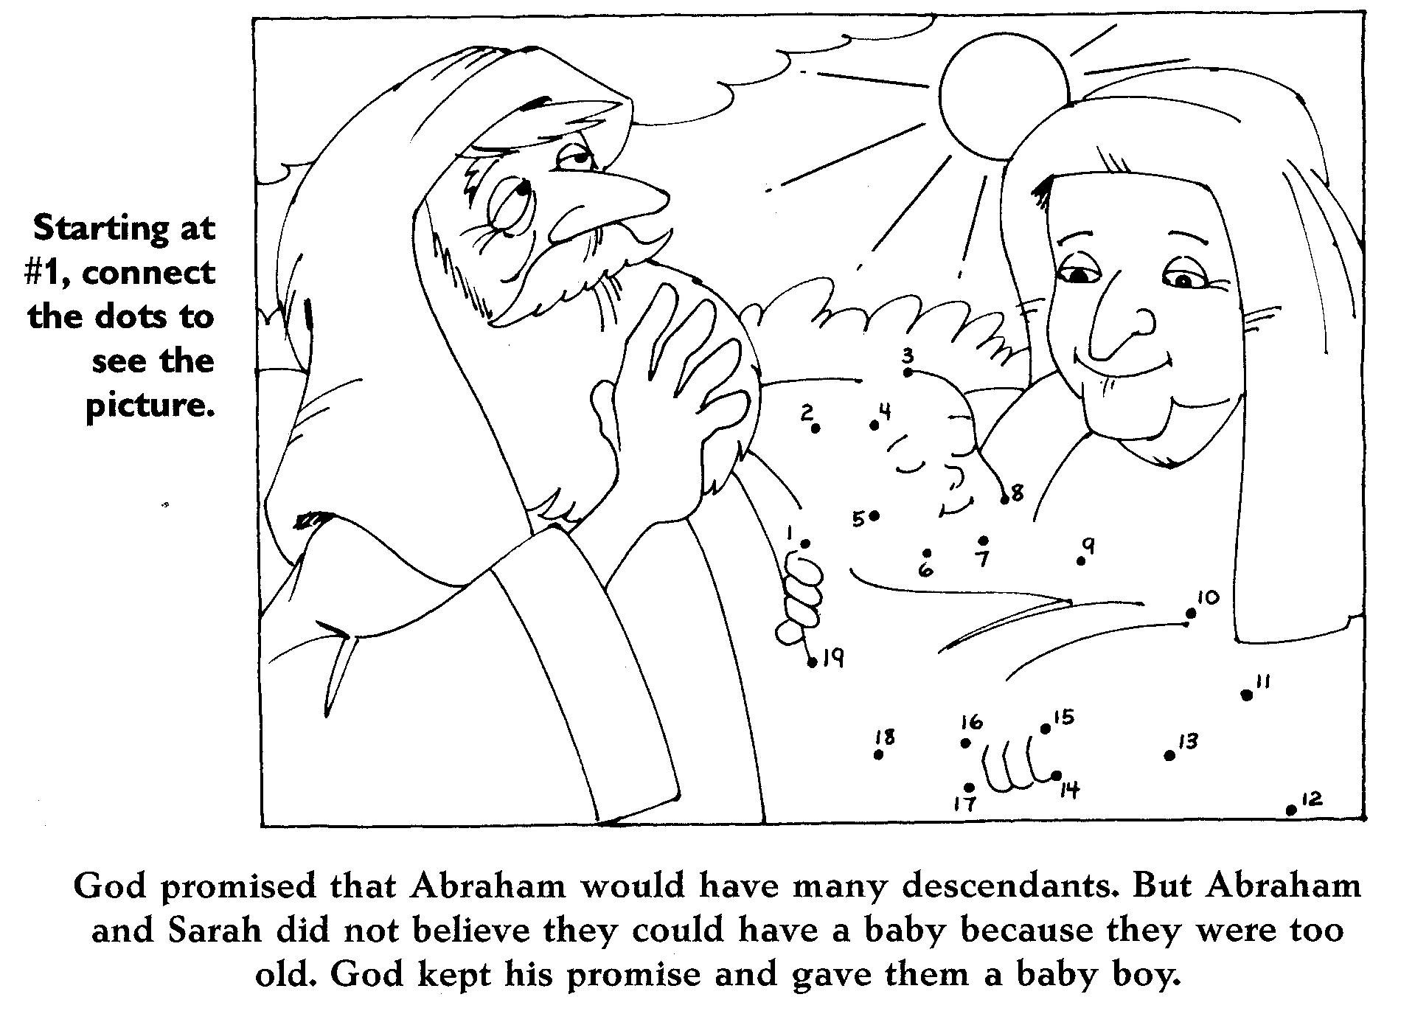
https://freesundayschoolcurriculum.weebly.com/uploads/1/2/5/0/12503916/lesson_11_isaac.pdf

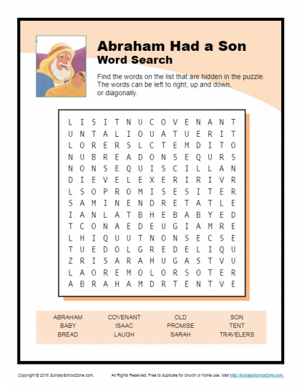

Teen Talk
Bible Verse: “Jesus replied: „Love the Lord your God with all your heart and with all your soul and with all your mind‟ ” (Matthew 22:37).

So I’m about to relate to you the rest of the story. If you happen to glance at the story for the younger from today’s lesson, it is all about Abraham and Sarah and the promise from God to bless them with many descendants……as many as the stars are in the sky. God kept his promise and when Abraham was 100 and Sarah was 90 years old, they had a baby boy named Isaac. Abraham and Sarah loved Isaac very much and they protected him because he was their only son. Now here’s where the story turns very dark. God spoke to Abraham one day and told him to go up to a certain mountain where he would lay Isaac down to be a sacrifice to God. Abraham without hesitation gathered the fire wood the next morning and set off for the long journey with Isaac. Wait a minute…… did I hear right?? Abraham WITHOUT hesitation was going to obey God and KILL his only son??? It’s what you would call OBEDIENCE. Abraham’s priority list had God right at the TOP, number one!!! There was nothing else that was more important to God in value, not even his only son. Now remember how long Abraham had to wait for this only son. Abraham was after all 100 years old when he had a son…….that’s a long time to wait. Isn’t it?? Abraham’s willingness to give up what was most important to him, to make a sacrifice of his son, Isaac, revealed his love for God. Now before you get all upset let me just put your mind at ease because God was just testing Abraham. Just as Abraham was ready to put the knife to Isaac. The Lord’s angel shouted from heaven, “Abraham! Abraham!” “Here I am!” he answered. “Don’t hurt the boy or harm him in any way!” the angel said. “Now I know that you truly obey God, because you were willing to offer him your only son.” Abraham looked up and saw a ram caught by its horns in the bushes. So he took the ram and sacrificed it in place of his son. Abraham named that place “The Lord Will Provide.” And even now people say, “On the mountain of the Lord it will be provided.” Genesis 22:11-14
So what do you think God might ask you to give up to make Him your number one priority?? Maybe it’s our money or our electronics or maybe it’s that sport that we to like to play or watch. After all how many times have you thought to yourself……. I should read my Bible, I should go to church, I should pray. Think really hard the next time this choice has to be made. What would we have to give up in order to put GOD FIRST? The next time you have that decision to make think of Abraham and that he was willing to sacrifice his son Isaac because God was his NUMBER ONE.

Watch this video clip of Abraham and Isaac:
https://www.youtube.com/watch?v=bxsIGuEiy-Q
You Tube video: Who You Are To Me-Chris Tomlin & Lady A:
https://www.youtube.com/watch?v=ZMzWBLzgi1Q

