**Kid’s Corner Week 22**

**Bible Verse: Make thee an ark of gopher wood; rooms shalt thou make in the ark, and shalt pitch it within and without with pitch**. **Genesis 6:14 KJV**

**And of every living thing of all flesh, two of every sort shalt thou bring into the ark, to keep them alive with thee; they shall be male and female. Genesis 6: 19 KJV**

Wow!!!! We have just completed the Creation of the world and the Fall of the world. This leads us to God’s order to Noah to build a boat or ark, made out of gopher wood, load it up with two of every animal-male and female to be saved from the flood. Why would God want Noah to build an ark?? And why would he want Noah to load it up with the animals to protect them from a flood?? Well, unfortunately the day Adam and Eve ate the fruit from the tree that God told them to never eat was the day that sinning against God and fellow man started. The disobedience just kept getting worse and worse until God was ready to destroy the sins of the people. He decided to send rain to flood the earth. Only Noah, his family and the animals would be saved because Noah was the only good and faithful man. God was happy with Noah but very angry about the many sins of all the other people. The ark would save them. Noah obeyed God and built the ark. It must have taken Noah many years to build this large boat called an ark. But finally it was finished. Noah’s family loaded it up with the animals and the

food to feed them. Next the rain started to fall and Noah and his family closed the doors to the ark. It rained for forty days and forty nights and everything on the earth was destroyed. The rain stopped and Noah waited for the waters to dry up. He wanted to see if there was any dry land so he sent a raven out. It came back because there was no dry land. Then he sent out a dove but it to could not find any dry land either. He waited a little longer and sent another dove out that came back with and olive branch in its mouth. The flood waters were finally

going down!! The ark rested on a mountain and Noah, his family and all the animals left the ark. Noah built an altar to pray and thank God for saving them. God sent a rainbow as a promise to never send a flood to destroy the earth again. Every time you see a rainbow remember this promise.

Watch this link for Arky, Arky Kids video:

<https://www.youtube.com/watch?v=DSxd9JVE3r4>



https://www.bibletimefun.com/

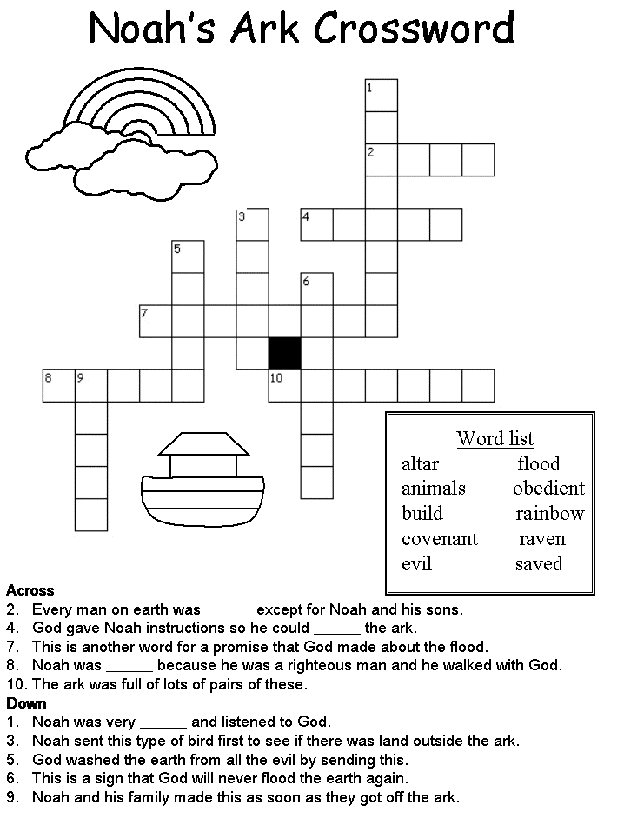

**www.dltk-kids.com**

**Teen Talk**

**Bible Verse: And Noah did according unto all that the Lord commanded him. Genesis 7:5**

Do you guys remember the Noah’s Ark story. God told Noah, the only good man left on earth, to build an ark, fill it with his family and two of every animal, close the doors and wait for it to rain. Wait a minute…….did you just hear right? God wanted Noah to build a ginormous boat in the middle of dry land. Why would Noah want to build such a thing when he lived nowhere near a large enough body of water to support it. And to top it all off Noah was supposed to fill it up with hundreds of animals that would need tons of food to live on when the great flood came. You know from the story in Genesis that Noah OBEYED GOD!!! That’s right even though Noah probably did not believe God at first, Noah listened and obeyed.

Watch this clip from the movie Evan Almighty <https://www.youtube.com/watch?v=80x9FmKsyg4>

I watched this movie when it first came out in 2007 and I thought it was really funny. As in the Bible, God tells Evan, a Congressman to build an ark that is roughly the same size as the one in the book of Genesis. Evan balks at first but God says to Evan, “People want to change the world but they don’t know where to begin.” God then tells him “it starts with one random act of kindness at a time.” God miraculously fills the bowl up with water for the stray dog that has been hanging around Evan’s house, which illustrates an act of random kindness that God has been talking about. So Evan obeys God and learns some valuable life lessons while carrying out God’s command. When is the last time that you were supposed to listen and obey God? Many times we know what’s right, yet we choose to do the opposite.

The other really cool thing about the story of Noah is that God speaks to human beings, which happens over and over in the Bible. The problem is that the people he is speaking to don’t always listen and obey. Do you hear God when he is trying to talk to you??? Do you try to talk to Him?? God would love to have a personal relationship with you. He would love to hear you pray and see you read his word. God is happiest when you are loving and obeying Him and your neighbor!