Kid’s Corner Week 21
Bible Verse: But of the fruit of the tree which is in the midst of the garden, God hath said, Ye shall not eat of it, neither shall ye touch it, lest ye die. Genesis 3:3 KJV

Hi everyone, Hope you all had a wonderful week. The weather has been really beautiful. It is

the season of fall and the leaves are starting to really fall off the trees. There are several

definitions for the word fall. The definition of the word fall that I want to concentrate on today

is to commit sin; yield to temptation. This is exactly what we call what happened to the first

man and woman that God made. This first sin is referred to as the fall of mankind. God placed

Adam and Eve in the Garden of Eden, gave them everything they wanted but only gave them

one rule which is written above in the Bible Verse. God told them they were not to eat the fruit

or even touch the tree of the Knowledge of Good and Evil or they would surely die. It seemed

like an easy rule to follow until a certain snake came into the picture. The devil or Satan as

some like to call him was disguised as the snake. Satan hated God. Satan wanted to be God

Satan tempted Eve and then she tempted Adam to eat the fruit of that tree. They DISOBEYED

GOD. THIS IS WHAT IS CALLED THE FALL!!! Adam and Eve were tempted by the snake/Satan

and committed the first sin. What did God think about his? You’re right, God was very angry.

God cursed the snake. He punished Eve and Adam too. God punished them because they

disobeyed Him. God did give them some Good News on that sad day. He promised them that

one day someone would come and crush Satan’s power over people. That day was a long way

off though. For now Adam and Eve had to leave the Garden of Eden. They would no longer

live forever. They would know hunger, suffering and death. They had turned away from God!!

Who do you think came into the world to crush Satan’s power over people?? If you said Jesus,

you are right. Jesus came as the LIGHT of the World. His light can lead you away from sin. You just have

to ask him to forgive you and to come into your heart to live. Then you get to have eternal life and live

with Jesus, His father, God and the Holy Spirit in heaven. Open your EYES AND YOUR HEART to the

LIGHT OF THE WORLD TODAY!!! FOLLOW JESUS!!
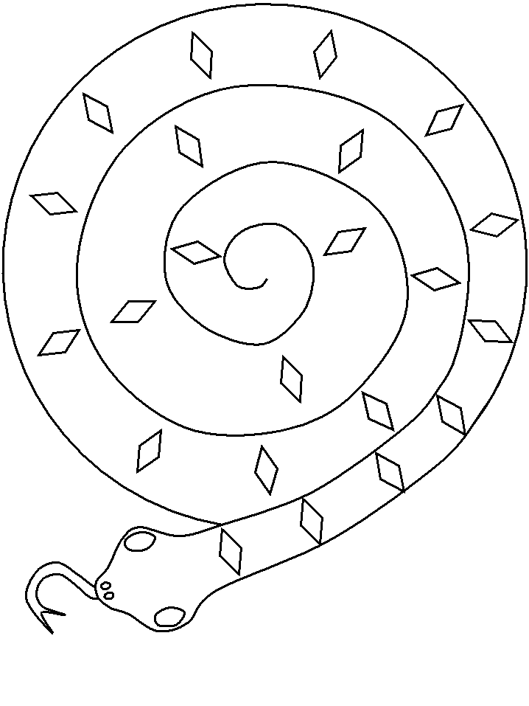
https://www.dltk-kids.com/t.asp?t=https://www.dltk-kids.com/animals/image/bspiralsnake.gif

Color this Snake then cut along the lines to make a coiled snake.

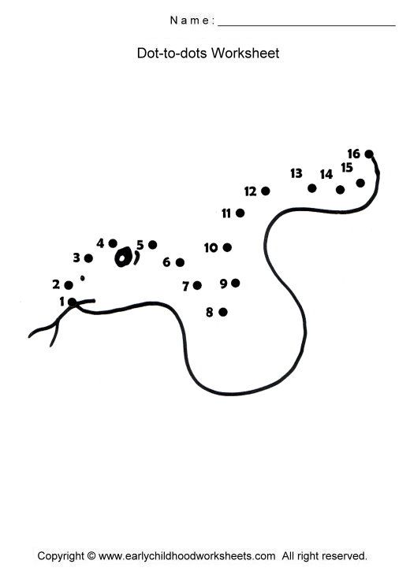Teen Talk
Bible Verse: For God so loved the world, that he gave his only begotten Son, that whosoever believeth in him should not perish, but have everlasting life. John 3:16 KJV

I am going to talk about the Fall of Man today. So why would I choose this very favorite Bible verse of mine??? Well for the last six weeks we have been talking about the creation of the world. Last week we talked about Adam and Eve. God waited till the sixth day to make Adam and then Eve. He created everything in order. Remember man had dominion or rule over creation and was created in the likeness of God. Adam and Eve were given one and only one rule; to not touch or eat the fruit of the Tree of Knowledge of Good and Evil that was in the center of Eden. They could eat of any other tree but not that tree. There’s something about being told not to do something that makes it all the more appealing. Now Adam and Eve had everything they wanted and they were living in a paradise but along came Satan in the body of a snake to forever change their lives and our very lives. Satan convinced Eve that she would be as smart as God if she would just eat that fruit. And then of course she talked Adam into doing the same thing. As soon as they ate the fruit they knew that they had sinned. They knew they were naked so they covered their bodies. All their innocence was gone because they disobeyed God. God was angry at them. He asked Eve why she had eaten the fruit and given it to Adam. She replied that the snake had tricked her. God told the snake that he was cursed to slither on the ground from now on. He also told him that he would make a way for the Eve’s descendants to be free from the sin that she had inflicted upon them. That is where my favorite Bible verse comes into the story. The Way is Jesus Christ. Jesus is the Way, the Truth and the Life!!! Although God punished Adam and Eve by sending them out of the garden to a life of suffering and then death, he said, “ And I will put enmity between thee and the woman, and between thy seed and her seed; it shall bruise thy head, and thou shalt bruise his heel.” This meant that one day Jesus would conquer Satan and bring salvation to the people of God. God would send his Son to the earth as a living sacrifice for the sin that Eve and Adam first committed. Wow!!! That is a lot to digest but God loves each and every one of us and wants us to have eternal life. All we have to do is ask forgiveness for our sins and give our hearts to his Son Jesus Christ. Just think God always had a plan for you and I to live with him forever in paradise!! Watch this short video about the Fall of Man https://www.youtube.com/watch?v=D7LZnMHYrmY

