Kid’s Corner Week 20
Bible Verse: And God said, Let us make man in our image, after our likeness: and let them have dominion over the fish of the sea, and over the fowl of the air, and over the cattle, and over all the earth, and over every creeping thing that creepeth upon the earth. Genesis 1:26 (KJV)
And the rib, which the Lord God had taken from man, made he a woman, and brought her unto the man. Genesis 2:22 (KJV)

So here we are almost at the end of God’s glorious creation. In the previous weeks we learned

that God made day and night, the sun, moon and stars, the sky, oceans, land, plants, fruits,

animals and today we are learning about God creating man and woman. The first line of the

verse says, “And God said, Let us make man in our own image,” This tells me that God looks like

you and me. God made the first man, from the dust of the ground and He breathed life into

him. The verse from today also says that the man had “dominion” over all the creatures that he

made. Dominion means to rule or have control, so God wanted Adam to rule over His many

creatures. Now the second Bible verse for today tells us how God made a woman to keep the

man company. God called the man, Adam and the woman, Eve. And God put them in His

garden called Eden. It was a beautiful garden with all of God’s creations in it. Adam gave the

names to all of the creatures in the garden. He named them all. Then from Adam and Eve God

made children and grandchildren. God made many more people. Then God made us……. you

and me. God knew what we were like before we were born. God knows what we say, what we

do, where we go. He knows about us all day and all night. God made us. We all are

descendants from Adam and Eve, the first people that God made. Remember God made us in

His own image. He wants us to love Him and love others. Be mindful to pray to Him every day

And thank Him for all your blessings!!!!

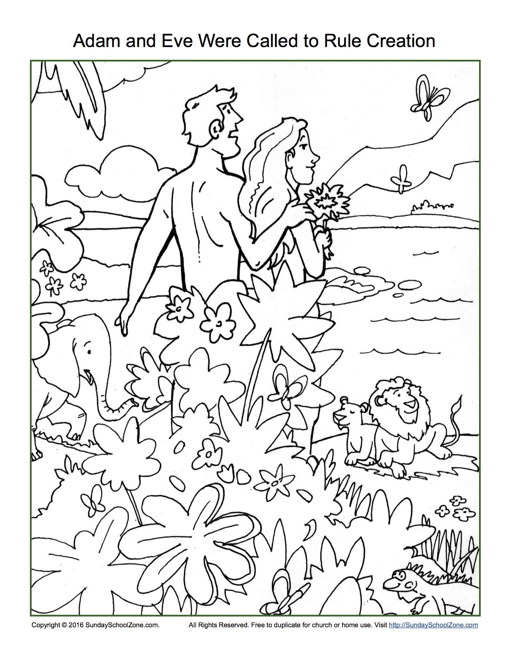

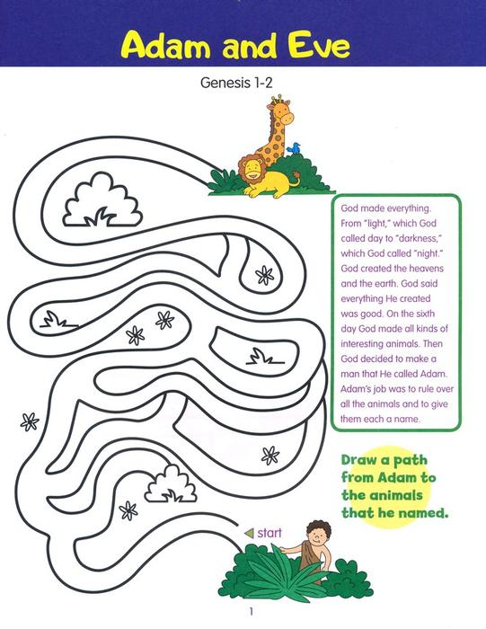
Copyright © 2020 One Stone Biblical Resources.

Teen Talk

Bible Verse: And God said, Let us make man in our image, after our likeness: Genesis 1:26 KJV

And the Lord God formed man of the dust of the ground, and breathed into his nostrils the breath of life; and man became a living soul. Genesis 2:7 KJV

Wow!!!! On the sixth day of creation God saved the best for last……He created man!!. We were

created in His image and likeness. Because we are created in the image of God, we need to

respect and honor God and each other. We must treat everyone with respect. That is God’s

way and he wants it to be our way. God wants us to love him first and then our neighbor. He

wants us to have eternal life someday in heaven with Him, His son, Jesus and the Holy Spirit. It

is significant that God formed the first man, Adam from the dust of the earth because one day

our body will return to dust but what about our soul? The verse says, “and man became a living

soul.” What exactly does that mean? A soul in the dictionary means, the spiritual or immaterial

part of a human being, regarded as immortal. That’s a lot to swallow… so it means that God

made the spiritual part of man too when he was created. Because he could think, love and

choose, Adam was a living soul. He could use his mind to think, his emotions to love and his will

to choose. Adam had very high intelligence just like God. Remember God gave him the difficult

task of naming all the animals. I don’t know if I would have been up for that challenge!! But

Adam was created in God’s image so he could perform that feat. As far as love goes we know

that God is Love so when God made Adam he was full of God’s love and emotions. And then

we come to Adam’s will to choose. God has a free will so Adam was like God and had free will.

Adam could choose to obey God or he could choose to disobey God. Adam was responsible for

his own choices. This is what separates man from all other living creatures: his mind, emotions

and will. So why was man created, you might ask? Isaiah 43:7 says, “ I (meaning God) have

created him for My glory.” We have been put on this earth to glorify God, worship God, to

love God and to fellowship with God. Please remember this that God made everything from

nothing. He is our all-powerful, loving creator.

Watch this Chris Tomlin video-Indescribable: https://www.youtube.com/watch?v=r4-tGQD6sUA
And this one too-How Great is Our God: https://www.youtube.com/watch?v=cKLQ1td3MbE

