Kid’s Corner Week 23
Bible Verse: The Lord had said to Abram, “Go from your country, your people and your father’s household to the land I will show you.

Hi kids……Have you ever moved from one place to another?? Well, when I was 15 I had to

move from Pittsburgh PA to Baltimore, MD. It was kind of scary to move that far away but I

survived. I obeyed my mother and everything worked out. Abraham obeyed God and moved

all his family and his belongings from his home in Haran to his new home in Canaan. Abraham

was a part of God’s plan long ago. God told Abraham that he would make his name great and

bless him as well. Abraham agreed to follow God’s plan and took his wife and his nephew Lot

and started traveling. While Abraham was traveling God appeared to him and told him of His

plan. Abraham built an altar to remind his family of God’s plan. He and his family kept

traveling until God gave the order to stop in Canaan. God blessed Abraham just as He said He

would because Abraham followed God’s plan. God promises that He will take care of us and

bless us too. He has wonderful plans for each and every one of us. We learn of God’s

plans through Bible stories and Sunday School. We must have faith in Him, hope for his plans

and love for God and our fellow brothers and sisters.

Watch this video of the song Father Abraham:
https://www.youtube.com/watch?v=y3DjT6kS4-4

Read Your Bible and Anglican Prayer Book!!!

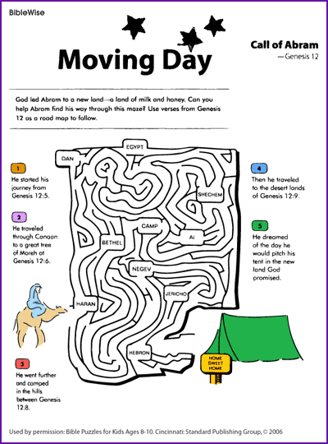

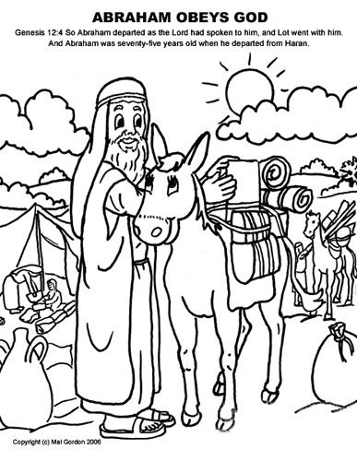

Teen Talk
Bible Verse: By faith Abraham obeyed when he was called to go out to a place, which he was to receive as an inheritance; and he went out, not knowing where he was to go.
Hebrews 11:8 (NIV)

Have any of you ever been lost??? If you have, it was surely a scary feeling. I was lost once with

my oldest son when he was about 12 or so. We were at a park and went down a trail that twisted,

turned and was not well marked. Before we knew it everything looked the same and we were

lost. To make matters worse a storm was coming. I did my best to pretend I knew where we

were, but my son looked at me and said, “ Are we lost Mom?” I said we were lost but I was

sure we would find our way back. That was a leap of faith because I was truly scared deep

down. Well with a little help from above we found our way back to the trail and back to the

parking lot. I breathed a sigh of relief as the skies opened up and it started raining.

“A leap of faith.” What exactly does that mean?? Well for me that day I knew that we were in

God’s hands and he wasn’t going to let us down. I think that was certainly how Abraham felt as

he heard God’s voice telling him to leave his country and go to the land that God was going to

show him. Abraham, a man of 75 years old, must have implicitly trusted God as he did what

God asked him to do. He gathered up his belongings and his wife, Sarah, and his nephew, Lot

and started out from Haran to travel to an unknown land. He put ALL his trust in God. God

told Abraham, “ I will make you a great nation, and I will bless you; I will make your name great

and you will be a blessing.” Genesis 12: 2 Abraham knew that God had a greater purpose for

him. He was faithful in serving the Lord. In the coming weeks we will be learning why

Abraham is called the father of all who have faith.

Watch this Video : Faith-Jordan Feliz
https://www.youtube.com/watch?v=PVc9VQiTMWs
And this video from Passion 2020 concert: There’s Nothing that Our God Can’t Do
https://www.youtube.com/watch?v=5MChgCghLJg

