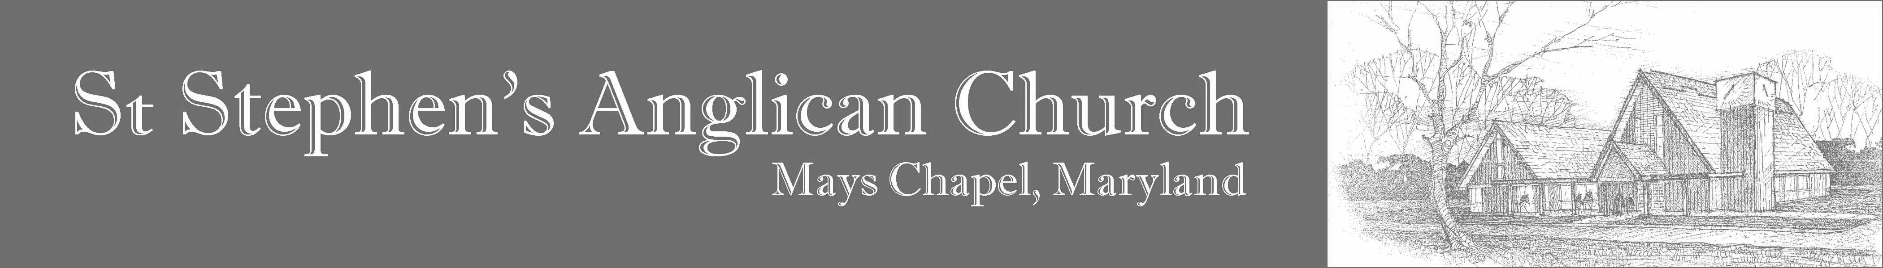
Greetings!

St Stephen's Anglican Church will hold its seventeenth annual British Garden Party and Fête on Saturday, May 9th, 2020, from 11:00 AM to 3:00 PM. This Garden Party is an afternoon of fun for all ages. There are games for adults, and games and activities for children; a tea room and an English pub; a White Elephant table; a genuine Punch & Judy show; and music and dancing.

We would like to invite you to become a sponsor of our event. The Garden Party is attended by hundreds of people from around the area, and each attendee is provided with a Programme. (Feel free to ask to see a sample.) To advertise, you may choose from the following options (please check one):

- _____ 6" by 7.5" $100.00 — full page
- _____ 6" by 3.6" $50.00 — half page (horizontal)
- _____ 2.8" by 7.5" $50.00 — half page (vertical)
- _____ 2.8" by 3.6” $25.00 — quarter page

(The Programme is printed on legal paper folded in half, so each page is nominally 7" x 8.5", but we have to leave room for margins.)

You may choose from the following options for the content of your advert:

- Submit photo-ready copy in JPEG or PDF and email to petrus@ststeve.com.
- Provide a business card to be scanned: mail it to St Stephen’s (see address below).
- Provide a message if you would like us to design something for you. Email to petrus@ststeve.com or mail to St Stephen’s (see address below).

Payment should be in the form of a cheque payable to St Stephen’s Anglican Church and mailed to:
St Stephen’s Anglican Church
11856 May’s Chapel Road
Timonium, MD 21093

Advert material and payment must be received by Thursday, April 30th, 2020, to ensure inclusion in the Programme. (You will be provided with a courtesy copy of the Programme, but we hope you will join us at the Garden Party.)

If you have any questions, please feel free to give St Stephen's a call at (410) 560-6776.

Sincerely,

