Kid’s Corner Week 9
Bible Verse: But I say unto you, Love your enemies, bless them that curse you, do good to them that hate you, and pray for them which despitefully use you, and persecute you. Matthew 5:43-44

Wow Kid’s!!!!! The Bible verse for this week as we celebrate the 4th of July could prove to be

difficult in real life. We find it very easy to love our parents, brother’s, sister’s, friends,

teachers. They love us and we love them. But what about the bully that is mean to you at

school, or someone who tells a lie about you and gets you into trouble. Do you think you could

love them?? It would be really hard, but that is what Jesus wants us to do. Jesus was talking to

his followers on a hillside. This sermon is now known as the Sermon on the Mount. Jesus said

“You may have heard love your neighbors and hate your enemies but I want you to “Love your

enemies, and if someone does mean and hateful things to you, pray for them.” Jesus said

that when we love our enemies we are acting like children of God. We are being true

Christians. If we are only kind to our friends, what is so great about that? Everybody does

that!!! When we love our enemies our action demonstrates the love of God to others, it shows

others how to act and it may even turn our enemies into friends.

Happy Fourth of July!!!! Officially it’s called Independence Day and is a celebration about our

freedom as a nation. Remember freedom is a gift from God!!

BE THANKFUL TO GOD FOR YOUR FREEDOM TODAY AND EVERY DAY!

REMEMBER TO READ YOUR BIBLE AND CHILDREN’S ANGLICAN PRAYER BOOK!!!

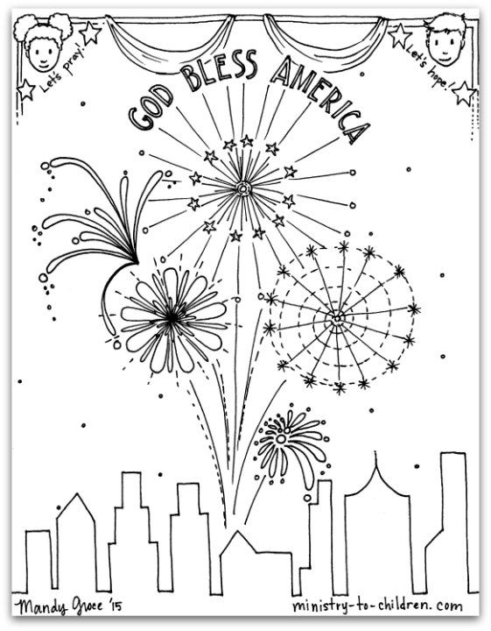

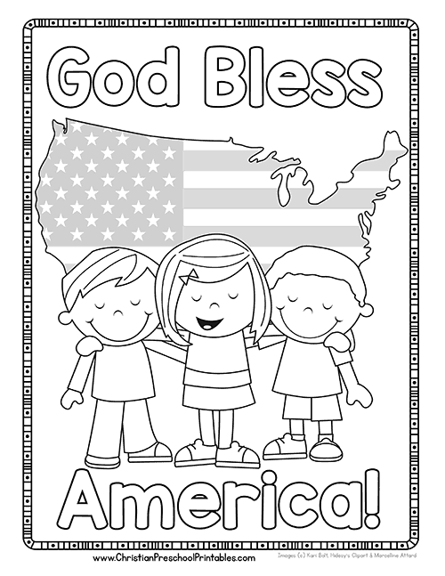
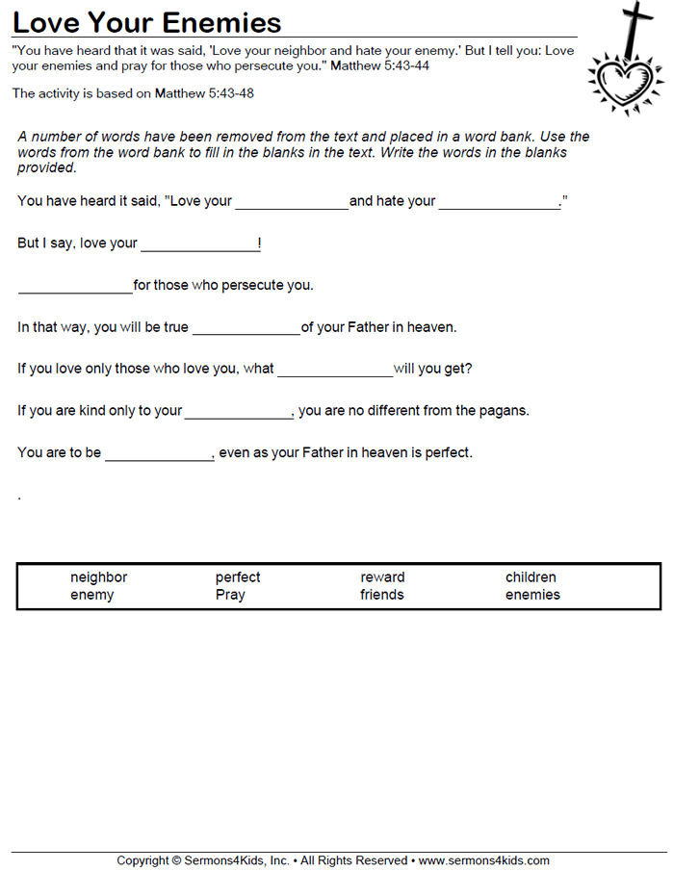

Teen Talk

For some this weekend will be filled with family cookouts and hopefully fireworks, weather and pandemic permitting as we celebrate the birth of our nation, Independence Day. It may be a little different this year but we are still celebrating something that we often take for granted- our freedom. The United States of America is a country that immigrants from all over the world want to make their home. Why? It can be explained in one simple word, FREEDOM!! That is why our Founding Fathers wrote the Declaration of Independence. You have probably all read that boring document in Social Studies class. Even if you don’t remember much……remember this quote,

“We hold these truths to be self-evident, that all men are created equal, that they are endowed by their Creator with certain unalienable Rights, that among these are Life, Liberty and the pursuit of Happiness.”

Life, Liberty and the pursuit of happiness can be equated with FREEDOM! This is why people want to live in this United States. Don’t ever take your freedom for granted as it is a gift from God!!

Another important point that many forget is that at least half of our founding fathers practiced some form of Christianity. Three of the Founding Fathers, George Washington, John Jay and Edward Rutledge were Anglican like us. John Adams and Samuel Adams were Congregationalists, Charles Carrol, Daniel Carroll and Thomas Fitzsimmons were Roman Catholic.
Ben Franklin, a Puritan and a signer of the Declaration of Independence and Constitution once said:
"Here is my Creed. I believe in one God, the Creator of the Universe. That He governs it by His Providence. That He ought to be worshipped. -Benjamin Franklin wrote this in a letter to Ezra Stiles, President of Yale University on March 9, 1790.
John Hancock, a Congregationalist and the first signer of the Declaration of Independence said:
"Resistance to tyranny becomes the Christian and social duty of each individual. ... Continue steadfast and, with a proper sense of your dependence on God, nobly defend those rights which heaven gave, and no man ought to take from us."
₋₋History of the United States of America_{, Vol. II, p. 229.}
This was just a small history lesson that hopefully you will remember as you celebrate this weekend!!
_{GOD BLESS AMERICA!!!}

.

