Kid’s Corner Week 6

Bible Verse: Beloved, let us love one another: for love is of God; and every one that loveth is born of God, and knoweth God. 1 John 4:7

This verse is actually the epistle for this Sunday. Have you ever heard the saying, “All you need

is love?” It’s also a song by the 60’s group, the Beatles. Why do you think they wrote a song

about love??? Well I think because love is so important to all of us here on earth. We love our

family and they love us. If we treat someone with love they are more likely to be loving to

us. We kiss to show our love, we hug to show our love, we obey our parents to show our love.

How can you show your love to your parents, friends or someone you just met other than what

I mentioned already? Flowers or a gift is a nice way to show someone you love them, but do

you know what is even better? It is better to show our love for someone by the nice things that

we do for them each and every day. When someone is sick, a visit from a friend might do them

more good than a dose of medicine. When someone is sad or having a bad day, a smile and a

friendly “hello” would surely brighten their day. Have you ever seen someone sitting all alone

at school who doesn’t seem to have very many friends? If you sat down and talked to them, it

might make them feel as if someone cares about them. A simple act of kindness can say a lot

more than a gift. Actions speak louder than words!!

God loved us so much that he sent his Son, Jesus to this earth to suffer and die on a cross so we

could be with Him in heaven.

Remember to read your Bible and Children’s Anglican Prayer Book

Kids: Write a special note inside this heart and give it to someone to show you love them.

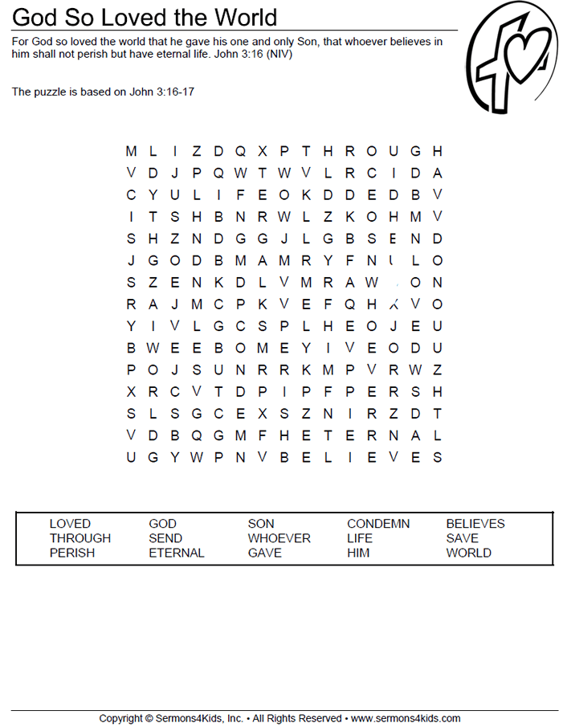

Teen Talk
I hope you are all looking forward to being able to get out of the house and slowly start doing

the things that you used to do like going to friend’s houses, playing sports, going swimming,

shopping, eating out and coming to church. We all have certainly missed seeing each and

every one of you. Have any of read one book of the Bible like I suggested in Week 2’s Teen

Talk?? I sure hope so. We certainly have had a lot of time on our hands during this pandemic

to do so many things. I’ve been painting my house, reading, organizing cupboards in my

kitchen, binge watching different shows on Netflix, Hulu and Amazon, and calling relatives

and friends. It’s helped me to pass the time. What have you been doing with your time?? I

hope loving one another is something that we all have been doing. We are all called to love

one another because God is love. We believe and love God and He wants us to love our

neighbor as we love ourselves. How can we show this love for our neighbor when there are

a thousand reasons to not love the next person? Some people are just unlovable because of

harsh words or actions against you or someone you may love. What does God call us to do

then?? Well if God can love you and me with all our shortcomings we can ask him to help us

love others the same way. Here are some things to remember when showing love:
- Show kindness in all situations.
- Be a good friend and listener.
- Learn to forgive and forget for it will demonstrate God’s love.
- Be slow to anger.
- Share the message of God’s love with others.

Some songs about Love:
https://www.youtube.com/watch?v=UEzCQBwQkdA
https://www.youtube.com/watch?v=44l9PRI4c2M
Bible Verse: 1 John 4:8 “Whoever does not love does not know God, because God is love.”

