Kid’s Corner Week 5

Bible Scripture: “Yet for us there is but one God, the Father, from whom all things came and for whom we live.” 1 Corinthians 8:6
“I and the Father are one.” John 10:30
“And I will ask the Father, and he will give you another Counselor to be with you forever.” John 14:16

This is Trinity Sunday!!! What does that mean exactly? If you look up the word

trinity in the dictionary it states “a group of three”. The three that we are

focusing on today are God the Father, God the Son and God the Holy Spirit. God

the Father is the CREATOR of the world, Jesus taught his disciples to pray, Our Father, Which

art in heaven-that’s the Lord’s Prayer. God the Son came down to earth in human form to die

on the cross for our sins. Jesus is God in human form. Finally the Holy Spirit is the

Counselor/Comforter/Teacher that Jesus sent to take His place here on earth. The Holy

Spirit is God with us today.
This illustration gives us a pretty good idea of what we are trying to understand.

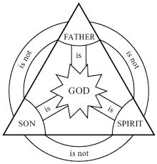
Or remember St. Patrick used a clover leaf to symbolize the Trinity.

We believe that there is only one God, but He is God in three persons: Father Son and Holy

Spirit.

Dear God, our Heavenly Father , our Savior, our Teacher, we praise you and worship you

today. Amen

Posted by Terry Enns in J. I. Packer, Trinity

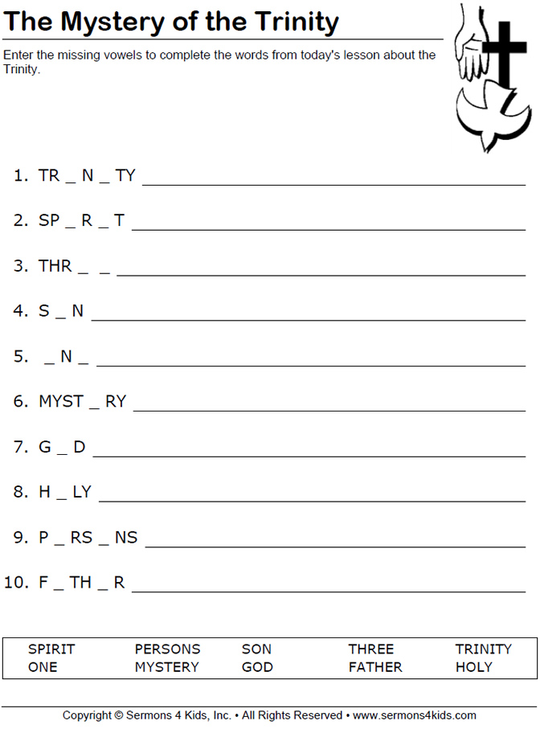

Teen Talk

This Sunday is Trinity Sunday. Which means that we are focusing on the three persons of God,

God the Father, God the Son and God the Holy Spirit. All through your Sunday School

education you have learned about the three persons of God. When some of you were very young

you sat in my class or Miss Tracy’s and made a paper plate creation craft. You may remember

about what God created in the first six days and how he rested on the seventh day. God made all

that we see on earth and in space. He is the creator. Then a little while later we concentrated on

the birth of Jesus, God’s only Son, his Life, Death and Resurrection. We made so many cool

crafts and played lots of games to remember these events. Most recently many of you have been

confirmed. This is when you were open to receiving the Holy Spirit and all the gifts of the

Spirit. You are now old enough to proclaim your faith, recite the Our Father/Lord’s Prayer,

General Confession and the Creed, know the 10 commandments, why you were baptized and

why the Lord’s Supper/Holy Communion is such an important sacrament as Mr. Brock has so

faithfully catechized each of you. You now go to the altar rail and receive the body and blood of

Jesus remembering that he died for you. You are all growing up really fast and I hope and pray

that we as Sunday School teachers have taught you the importance of God the Father, God the

Son and God the Holy Spirit. What an awesome and loving God we serve!

Has anyone come up with a Service Project for St Stephen’s that you teens can participate in when things are normal again??? I would love to hear your ideas!! Please tell your parents and have them email me.

Watch these two videos for some really good advice: https://www.youtube.com/watch?v=VAFMGRMhFsM

https://www.youtube.com/watch?v=pyuaDo1eLEI

