**Kid’s Corner Week 19**

**Bible Verse: And God said, Let the waters bring forth abundantly the moving creature that hath life, and fowl that may fly above the earth in the open firmament of heaven. And God created great whales, and every living creature that moveth, which the waters brought forth abundantly, after their kind, and every winged fowl after his kind: and God saw that it was good. And God blessed them, saying, Be fruitful, and multiply, and fill the waters in the seas, and let fowl multiply in the earth. And the evening and the morning were the fifth day. Genesis 1:20-23**

So here we are at Day 5 of God’s Creation. We have already learned how God made the day

and night, sky, land and oceans, rivers, seas, trees, flowers, fruits, vegetables, sun, moon, stars

and seasons. We’ve learned how God created this wonderful world. Today’s lesson is about

how God created all the different living creatures on this earth. The Bible verse above from the

first book, Genesis tells us that God made birds, ocean creatures like whales and all creatures

that live on land. He wanted them to multiply and live everywhere. God looked at all that he

had made and **SAW THAT IT WAS GOOD.** What is one of your favorite creatures of the land,

sky or oceans that God made? I have many!!! One of my favorites is the seal. I also like

kangaroos and wolves. There are many thousands of birds, over 200,000 ocean creatures and

over 6.5 million land creatures. Scientists say that there are many more that are still unknown.

Can you imagine how awesome it was for God to make all these creatures? I think He probably

had fun doing it!! Just remember our God loves us so much that He made all of these

wonderful creatures for us to enjoy!! Don’t forget to thank God for creating all of the incredible

creature of this earth. Remember he created **EVERYTHING** from **NOTHING**!!!!!!

**PLEASE READ YOUR BIBLE AND ANGLICAN PRAYER BOOK!!**



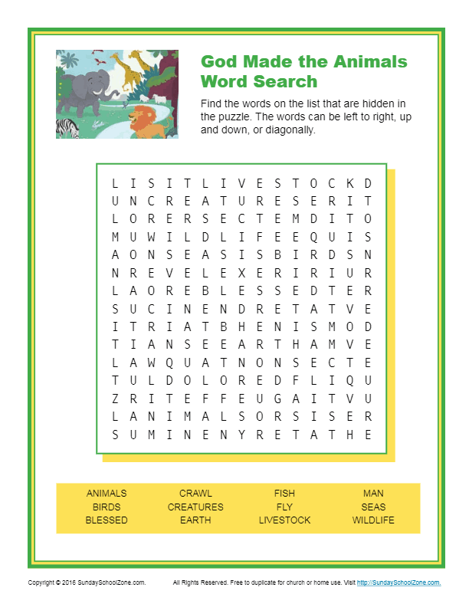

**Teen Talk**

**Bible Verse:** The earth is the Lord’s, and all its fullness, The world and those who dwell therein. For He has founded it upon the seas, And established it upon the waters.

Psalm 24:1-2 (NKJV)

This verse from the book of Psalms rightly says that this earth belongs to God. He is the one

who created it for us to live on. God is our loving Father and He wants us to love

him and enjoy His many creations. This week we are studying what God created that lives on

the land, sea and air. Have you ever been to the zoo or the aquarium? I have seen so many

different sea creatures, birds and animals at the Washington, Maryland Zoos and the

National Aquarium. I have seen things that I’ve never heard of before in my life. After all there

are thousands of birds, 200,000 ocean creatures and 6.5 million land animals. Each of us has

probably only ever seen just a small sample of these creations. I can imagine God had fun

making all these thousands of creatures. Just think of the difference between an octopus and a

flamingo. The last time I was at the aquarium I saw many unique stingrays swimming in the

tanks, poisonous frogs and really cool looking jellyfish. It is mindboggling to me that God

created all of these creatures from the small ant that can carry something that’s 10 times its

own weight to the sperm whale that eats up to 2000 pounds of food a day. God after all is the

**MASTER DESIGNER!!** He created these animals, birds and sea creatures and started the circle

of life. God is the one who started it all for His glory. He is a powerful creator and should be

respected and we also have to respect what He made.

**Enjoy the 10 Rarest and Awesome Animals video:** [**https://www.youtube.com/watch?v=Z07-Xeg8ftw**](https://www.youtube.com/watch?v=Z07-Xeg8ftw)**https://www.youtube.com/watch?v=hT93Yv1PuJs**