Kid’s Corner Week 18

Bible Verse: And God said, Let there be lights in the firmament of the heaven to divide the day from the night; and let them be for signs, and for seasons, and for days, and years:…….
and God saw that it was good. Genesis 1:14-18

Hi kids, we’re only going to concentrate on one part of this day 4 of creation: the seasons.

God had a plan to make four different parts of the year. These parts are called seasons. The

seasons are spring, summer, fall and winter. Our sun, moon and stars help us know the

different seasons. The plants growing and the weather changing can help us know which

season we are in. The Bible tells us that flowers grow in the spring. God sent rain in the spring

too. The rain helps new life grow like the leaves on the trees and the blossoms of flowers.

After spring comes summer which has long, warm, days. The days become shorter and cooler

and God changes summer to fall. The leaves are pretty colors and they fall off the trees. When

the leaves have all fallen off the trees and it turns cold then we know winter is here. God sends

snow to some places in the world. Now what are the four seasons of the year??? SPRING,

SUMMER, FALL AND WINTER!! God gave us these seasons to enjoy!! Which season is your

favorite?? Mine is summer because I like hot weather and traveling to the beach!!! We can

praise God for being smart and powerful. We can thank God for making spring, summer, fall

and winter!! As we approach the season of fall with all the beauty of the leaves falling from the

trees, let us think of the mighty power of God our Holy Father and how much he loves us.

READ YOUR BIBLE AND ANGLICAN PRAYER BOOK EACH DAY!!

Sing-a-long with this music video:
https://www.youtube.com/watch?v=agXEcDKmGCA

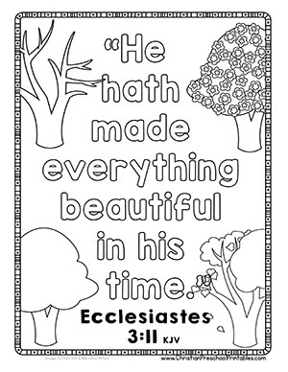
https://scriptureand.blogspot.com/2018/02/god-controls-season-childrens-lesson.html 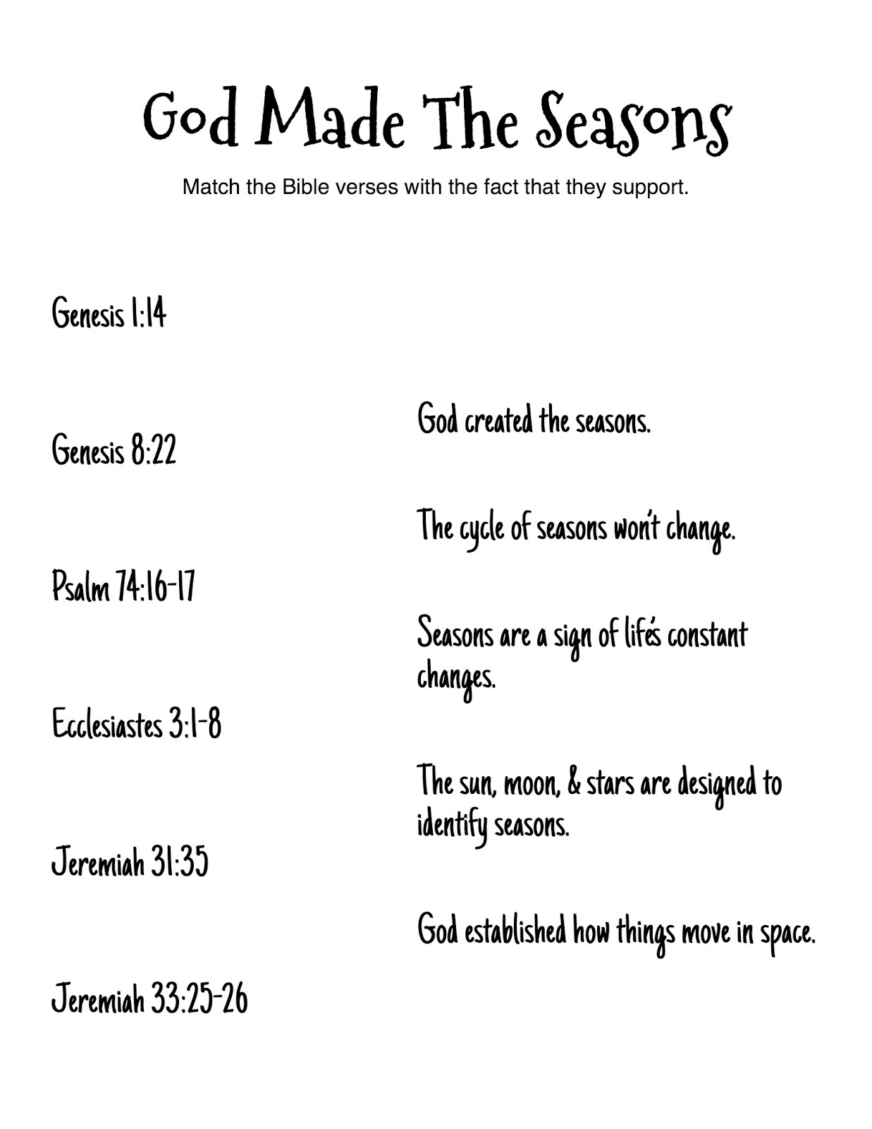

Teen Talk

Bible Verse: To everything there is a season, and a time for every purpose under the heaven:
Ecclesiastes 3:1 (KJV)

Why did I pick this verse?? Listen to this old song from October 1, 1965 by the Byrd’s called Turn, Turn, Turn to see how it relates to the above Bible verse.
https://www.youtube.com/watch?v=W4ga_M5Zdn4

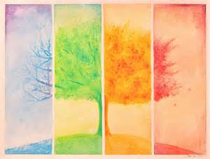
Make sure you read some of the comments too!

I’m sure when you were listening to this song some of you probably thought “Wow-this Sucks!!!!” It’s not at all what you are used to listening to. The days of Folk Rock are long past….now it’s Pop, Hip Hop, Rap, Rock, Country, Electronic Dance Music, and R & B according to two current sources from 2019 articles. But you see the 60’s were pretty turbulent times. There was rejection of traditional family relationships, religion, work ethic and education ideas. The Civil Rights Movement and the Vietnam War was also taking place which resulted in protesting, sit ins, boycotts and riots all in the name of change. Sound kind of familiar?? The writer of this song, Pete Seeger who is a great American folk singer actually wrote it in 1959. But the song didn’t really make it big until the Byrd’s recorded it in 1965, the height of the cultural revolution. Seeger said in a 1988 interview that, “I got a letter from my publisher, and he says, ‘Pete, I can’t sell these protest songs you write.’ And I was angry. I sat down with a tape recorder and said, ‘I can’t write the kind of songs you want. You gotta go to somebody else. This is the only kind of song I know how to write.’ So he wrote this song Turn, Turn, Turn in 15 minutes on a slip of paper. He wrote it using the King James Version of the Bible. The verses were written by King Solomon, David’s son but every verse is God inspired as all the books of the Bible are. Seeger quoted the Book of Ecclesiastes 3:1-8, but changed the order and some words. The song is basically comparing the changing seasons in nature to our lives and how they change too…….turn, turn, turn…….revolve like the sun, moon and stars that change our seasons here on earth. Our lives are affected by so many things, good and bad. This song is still applicable and can be related to today’s turbulent times. Our country is full of change right now, many opposing forces at work. Don’t fall prey to this uncertainty for GOD NEVER CHANGES. And scripture also says from Hebrews 13:8, Jesus Christ is the same yesterday, and today, and forever.(NKJV) We can trust and rely on the words of God the Father, God the Son and God the Holy Spirit. Have faith and pray, pray, pray!!!!

