Kid’s Corner Week 16

Bible Verse: And God said, “Let there be a vault between the waters to separate water from water.” So God made the vault and separated the water under the vault from the water above it. And it was so. God called the vault “sky” And there was evening and there was morning the second day.
And God said, “Let the water under the sky be gathered to one place, and let dry ground appear.” And it was so. God called the dry ground “ land, ” and the gathered waters he called “seas.” And God saw that it was good. Genesis 1:6-10

Our God is an awesome God isn’t he? Two weeks ago we discovered that God

made the day and the night which meant that he made the sun, moon and stars

and now Genesis verse 6-10 says that he made the sky, the land and the seas!!!

First God created the sky with air in it so man could breathe. God knew that we

couldn’t breathe water so he made the sky with plenty of air. There was water

everywhere but God knew that the next things that he made were going to need

a place to live too so he moved some things around so that the plants, animals

and people could live. That was called land. Some land is flat and some has

mountains and valleys. God had to do something with all the water. There was

so much. He gathered up the water in his powerful hands and placed it into

oceans, lakes, rivers, creeks and ponds. God is so powerful!!! God should be

praised for all the wonderful things he made. Let’s praise Him by

listening to the song “ Awesome God.”
https://www.youtube.com/watch?v=TfZX34Q6lIU
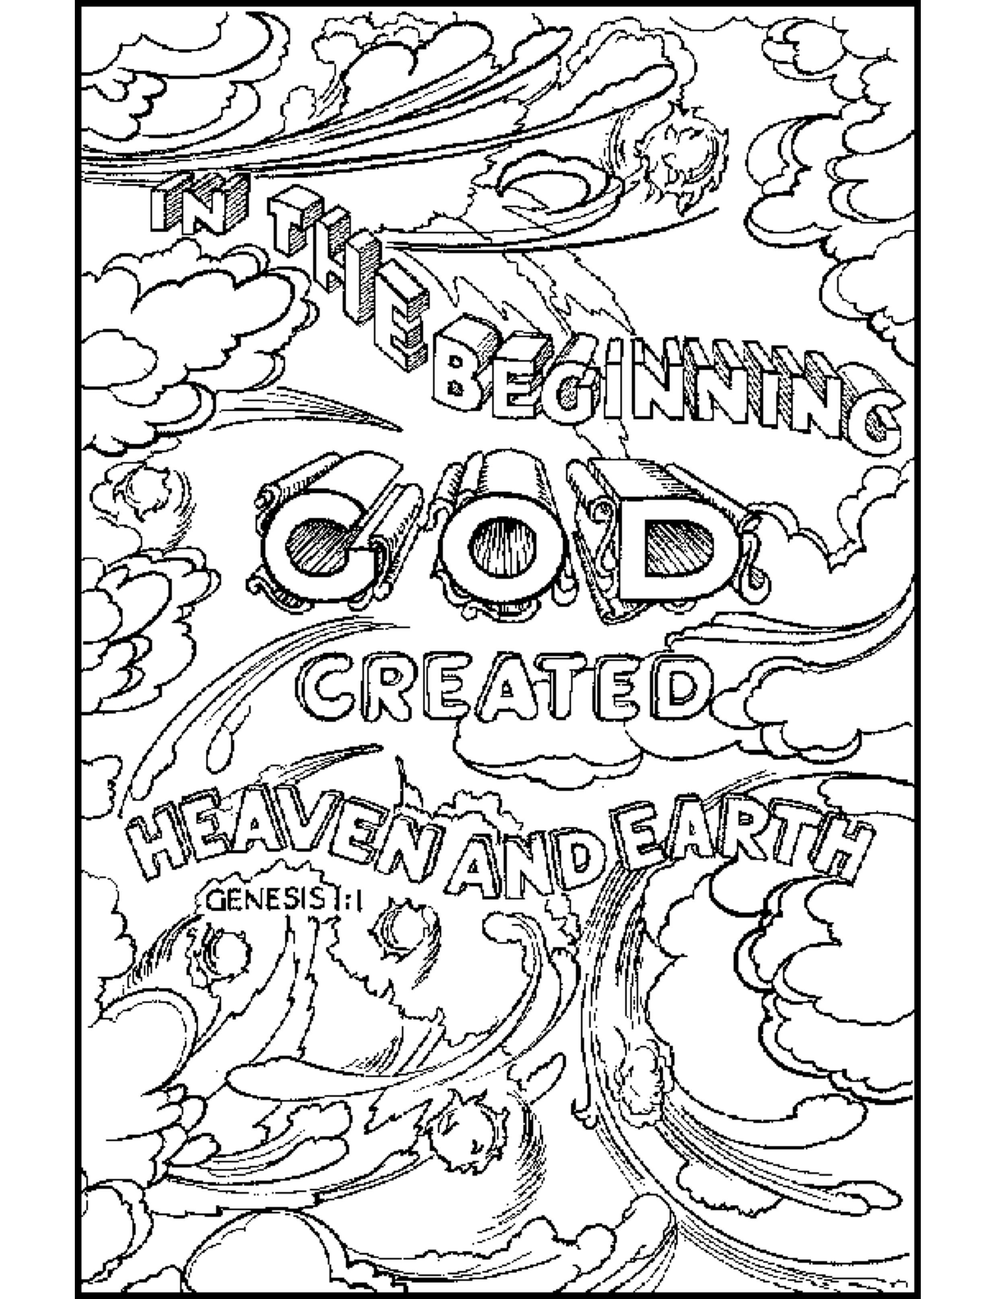
Copyright © 2020 The Scripture Lady

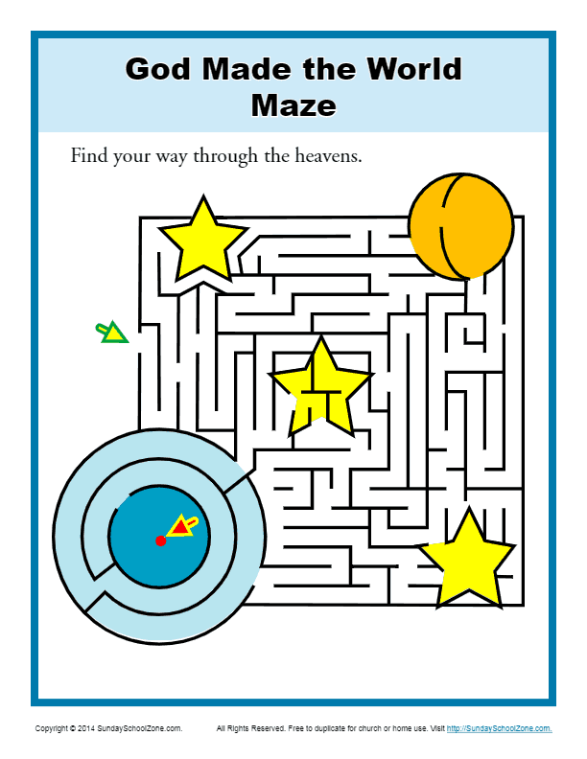

Teen Talk
Bible Verse- For ever since the world was created, people have seen the earth and sky. Through everything God made, they can clearly see his invisible qualities-his eternal power and divine nature. So they have no excuse for not knowing God. Romans 1:20 (NLT)

The above verse is not from the book of Genesis but instead the book of Romans written by

Paul the Apostle. Remember that Paul was known as Saul, a Christian hater and persecutor

that was blinded by Jesus on the road to Damascus. His eyes were later opened to the love of

Jesus Christ. Paul was a member of the Jewish priests, the Pharisees. Therefore we know that

he was a student of the Old Testament. We know that he thoroughly studied the book of

Genesis. His opinion of the creation is obvious. He feels that God did such a remarkable thing

when he created the earth and sky. He exhibited mighty power in that he was capable of

making all that we see around us. So Paul says simply that seeing all that splendor is knowing

our Father God!!!!

How many of you have been to the ocean or the mountains? I’ve seen the Atlantic Ocean many

times. I’ve been to the Western Maryland Mountains, Smoky Mountains and the Shenandoah

Mts. They are all so beautiful to behold. How many of you have flown in an airplane and gone

way up above the clouds!!! God created all of it!!!!! That’s what Paul is talking about: The

Power of God as seen in His Creation!! Do me a favor next time you see something awesome in

the sky, water or on land say a big Thank You to God and Praise His Name!!!

I was searching for a really cool music video but I found this God’s Picture Skit video. It starts

with Creation and has an awesome ending!!! Please watch:

https://www.youtube.com/watch?v=wMOk5rWPqwg

