Kid’s Corner Week 15

Bible Verse: Such trust we have through Christ to God-ward: not that we are sufficient of ourselves to think any thing as of ourselves; but our sufficiency is of God……… 2 Corinthians 3:4-5

Last week I started the Story of Creation and I only had one student come to Sunday School so I

decided to reteach it this week in the hope that more kids will come this Sunday. In the

meantime I want to talk about the Bible verse above. This verse is in the epistle or first reading

written by St. Paul for today. It is pretty wordy but to me It simply means: IT IS GOD WHO

MAKES US ABLE TO DO ALL THAT WE DO!!!!!

After all God created the world and he created each of us. He knew each of us before we were

even born. The Holy Trinity: God the Father, God the Son and God the Holy Spirit love us so

much. Jesus came to this world to die on the cross and rise from the dead as a living sacrifice.

When he went back to heaven he sent the Holy Spirit to take his place here on earth. God

gives us a free will to choose to ask Jesus into our hearts. God just wants us to love Him with all

our heart, soul, mind and strength. He also wants us to love our neighbor as ourselves These

are the two most important commandments that God gave us. He wants our love and he wants

us to love others too. God loves to hear us praying and singing to him and for him. God loves

to see us helping others and serving others. He smiles when we read our Bibles, say our dinner

prayers, sing in Sunday School, take a sick person a card or present, listen to our parents, and

tell the truth. Just remember with God all things are possible!!!

Read your Bible and Anglican Prayer Book!!!!!

https://sweethoneycomb.com.au/products/coloring-for-adults-bible-verse-matthew-19

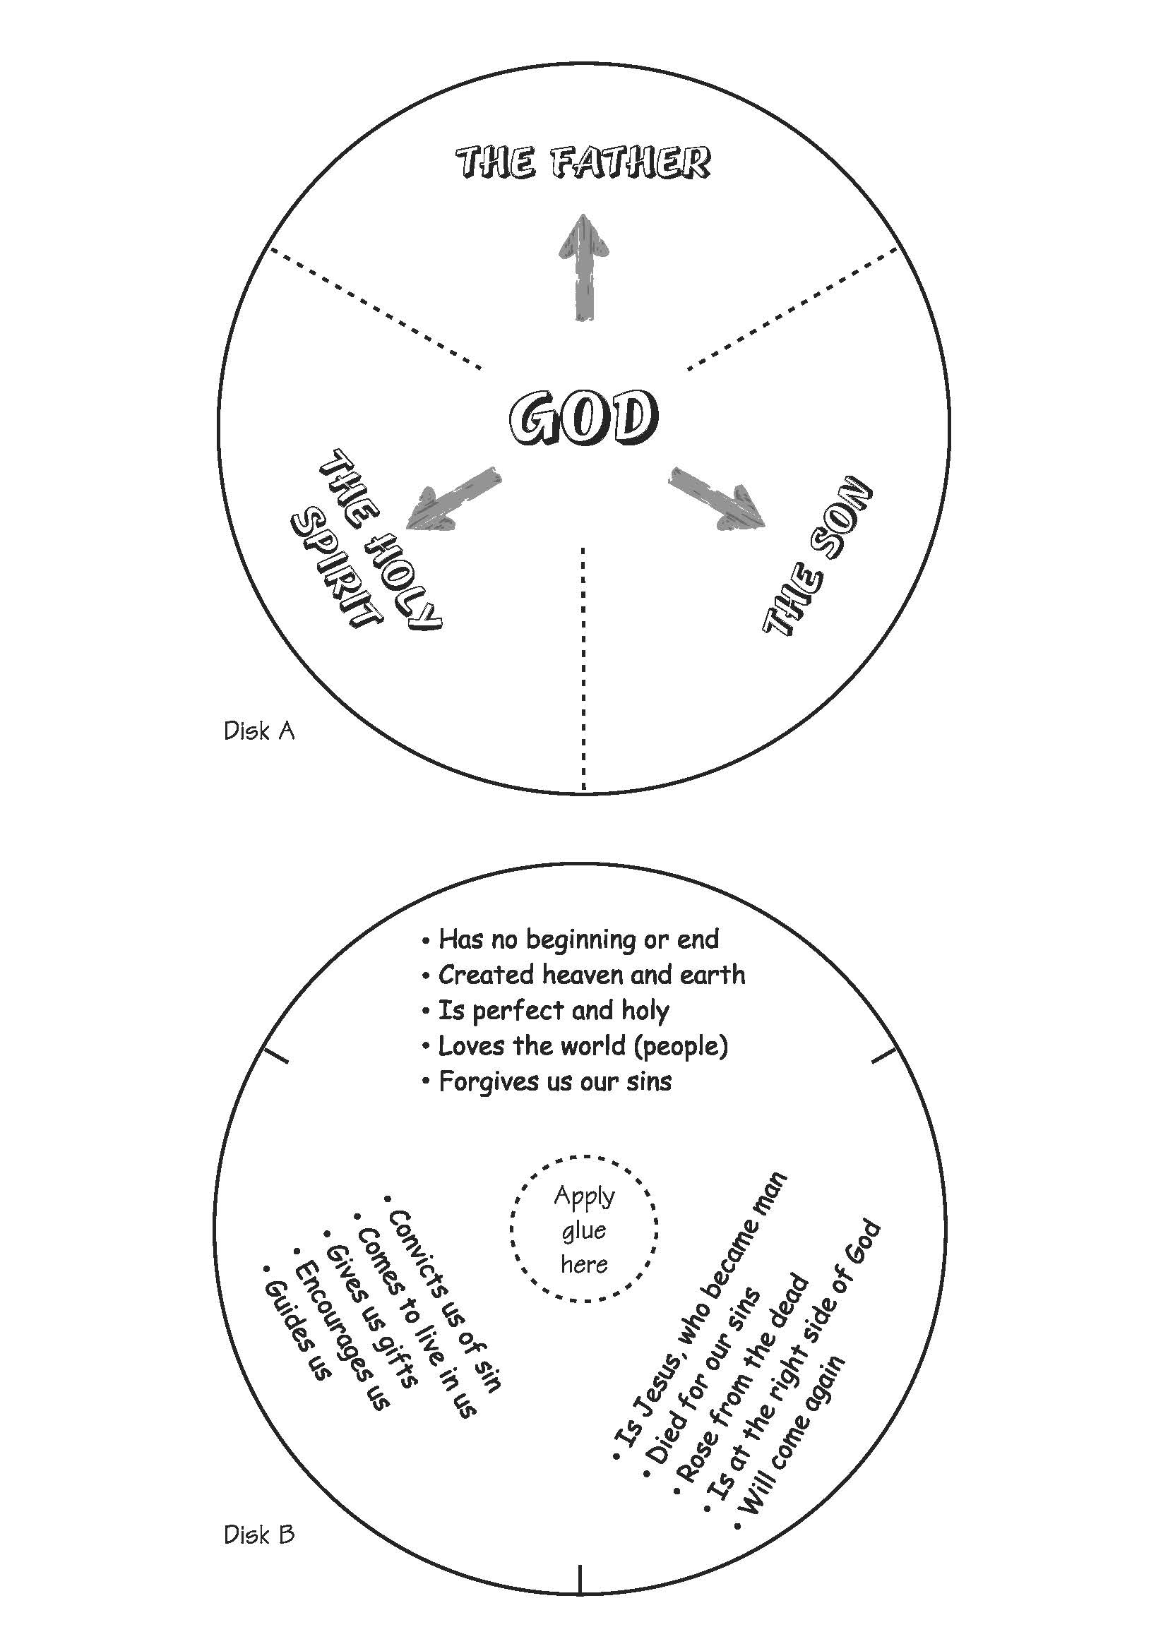
http://mycatechismclass.weebly.com/chapter-handouts.html
This is a great craft to remember the Trinity. Hope you have fun with it!!

TEEN TALK
Bible Verse: Don’t worry about anything, but pray and ask God for everything you need, always giving thanks for what you have. Philippians 4:6

Are any of you having some anxiety about starting school next week??? Well I would encourage

you to pray about it. In fact that’s what the Bible commands you to do. Put your faith in the

Lord Jesus Christ. Tell God what you are worrying about and feel the love that he can give back

to you. Do you find it hard to pray? Sometimes when I have trouble praying I go to the prayer

section of my Book of Common Prayer or I read my Bible. In fact at times my fingers find just

the right pages to go to help me with what I’m worrying about. Being a believer in God and His

son, Jesus does not guarantee that you will not have troubles in life. The book of James says,

“When you have many kinds of troubles, you should be full of joy, because you know that these

troubles test your faith, and this will give you patience” James 1:2-3, NCV

So troubles/worries test your faith and that testing is what helps the fruit of the spirit-patience

grow in our life. Your faith in God can be a witness for a friend or relative. The fact that you

trusted and prayed to God shows others how powerful God and Jesus can be.

Jesus himself said, “Come to me, all you who are weary and burdened and I will give you rest.”

Matthew 11:28 NIV

Just remember there are so many verses in the Bible that give us hope and wisdom to help and

encourage us with any problem.

Watch this video for encouragement:
https://www.youtube.com/watch?v=lR1Hk0FVi_k

