Kid’s Corner Week 14

Bible Verse: And God called the light Day and the darkness, he called Night. Gen 1:5

Hi Kids,

Have you ever had the lights go out at your house at night when it was dark outside? It was

kind of scary until your mom or dad scrambled to find a flashlight and turned it on. Did you

know that there was a time when there was nothing but darkness? There was no light at all.

It’s pretty hard to imagine but that’s what the world was like in the beginning. The Bible says

that God was there before there was anything else, even light. Out of the darkness, from

nothing at all, God created everything there is. That’s how powerful God is. Only God can

make something out of nothing. Then God decided to make light. He said, “Let there be light,

and there was light.” God wanted lights in the sky to light the earth. They would help tell if it

was day or night. God made two special lights. The biggest light was for the day. God called

this light the sun. We see the sun during the day. The smaller light was for the night. God

called this light the moon. God also made stars. We see the moon and the stars at night. God

looked at the day, the night, the sun, the moon and the stars that He had made. God saw that

they were good. The lights were just part of the wonderful world that God made.

Remember to read your Bible and Anglican Prayer Book
every day!!!!

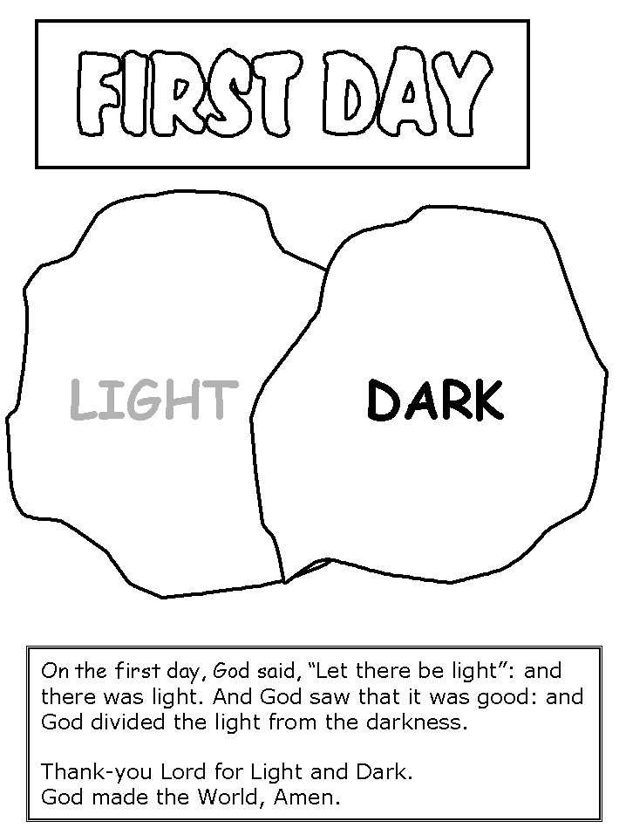

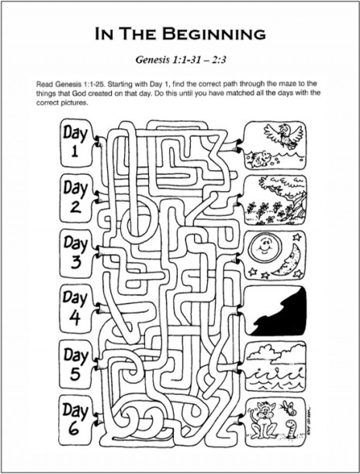
https://www.anythin.info/printable-creation-bible-activity-worksheets/
ONLY COMPLETE DAY 1 & 4 OF THE ACTIVITY
TEEN TALK
Bible Verse: So God created man in his own image, in the image of God created he him; male and female created he them. Genesis 1:27

Good morning everyone,
Hope your week was good!!! I’m sure many of you may be starting school this week. Most

everyone will be participating in Distance Learning again. Some of you may like this option and

others may not. We are all different in so many ways but we are alike in many ways too. After

all God created each and every one of us. He brought this whole wide world into existence out

of nothing. God is the only one capable of making something out of nothing!! The Bible verse

above is what happened on the sixth day……the creation of man!!! On days 1-5 God created

light darkness, sky, land and sea, plants and trees, the sun, moon and stars, sea creatures, birds

and animals. The sixth day was very important to God. He made man on the sixth day. Man

was special as he was in charge of the rest of creation in the Garden of Eden and he was made

in the image of God. God even named the man Adam and let Adam name each creature. But

one day God thought that Adam was lonely so he created Eve out of the rib of the sleeping

Adam. Now Adam had a special companion, Eve. When you’re reading Genesis 1, God’s words,

“And God saw that it was good.” are mentioned often. This shows that God is a caring and

powerful creator. Why do you think an all-powerful creator would create man?? Could he be

lonely?? Did he want a relationship with man, whom he created?? Because God created us in

his image we must respect God and all that he has made including our fellow man. God loves

us….. each and every one of us. In fact he loves us so much that He gives us the opportunity to

have eternal life someday in His kingdom, heaven. All he asks for in return is our love and

respect.

Video to watch: https://www.youtube.com/watch?v=O7bD02ZmTqk- Mercy Me

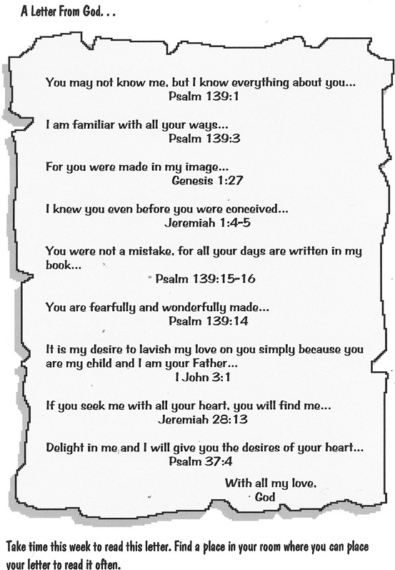

KingdomQuest_Elementary_Unit 1

