Kid’s Corner Week 13

Bible Verse: Now there are diversities of gifts, but the same Spirit. And there are differences of administrations, but the same Lord. And there are diversities of operations, but it is the same God which worketh all in all. 1Corininthians 12:4-6

Good morning Sunday School class,

Well here we are in week 13 of our lessons for the summer. My how time has flown. I miss each and every one of your smiling faces. I can’t wait until we can see each other again soon! I have been a Sunday School teacher here at St. Stephen’s since 2001. Way before you were born. Teaching Sunday School has been my spiritual gift to my church family. The Bible verse from today’s epistle or first reading is about different spiritual gifts that the Holy Spirit has given each and every one of us. God is the source of these gifts. We serve God when we use these gifts. God works in different ways but it is the same God who works in all of us. Miss Holly can teach songs to us and play the organ. Miss Tracy Collins and Mr. Brock are also Sunday School teacher’s that use their gift of teaching here at St Stephen’s. Mrs. Tracy Gushue helps to plan and run Vacation Bible School and Pretend Sleepovers. Kiki Gushue takes tender care of our littlest children in the nursery and Daytona, Al, and Kiki use their drama gifts to create puppet shows for Vacation Bible School every summer. Miss Happy is our pastoral nurse. She makes calls to different people that attend church here to make sure they are ok and to see if the church can help them. Miss Frannie Tilghman leads the Parish Life Committee and plans all the special events at church like the Cookie Walk and British Garden Party. Miss Cindy makes jellies for the Cookie Walk. Miss Mavis, Miss Happy, Miss Cindy, Miss Edie and others all knit or crochet blankets for babies or the elderly and scarfs, sweaters, hats to sell at the Cookie Walk for Heifer International. Mr. Bill Spicer and Mr. Gary Mullaney take care of the lawn and gardens at the church. Mrs. Linda Mullaney runs the Bingo to earn money for the Parish Life Committee. Mrs. Ellen Reather and other ladies set the altar and wash and iron the linens for the services. Ms. Devon Rust makes beautiful flower arrangements for the weekly services. Mr. Scott Taylor collects food, supplies and money for Jacobs Well which is a mission for the mentally ill. Father Guy and Father John are our priests that lead our church for God. There are so many different jobs and missions here at our church. All of our gifts and talents that we get from God can be used in some way to help the church and people in our community. This shows that we love God and our brother as He has told us to for GOD IS LOVE!!! You have a special gift that you can use here at St. Stephen’s but you must be ready and willing for God to use you to do His work .
Watch this video that compares Mr. Potato Head and his parts to the church and us. Where do you fit in??
https://www.youtube.com/watch?v=rQjb8wMcrGk

READ YOUR BIBLE AND CHILDREN’S ANGLICAN PRAYERBOOK!!

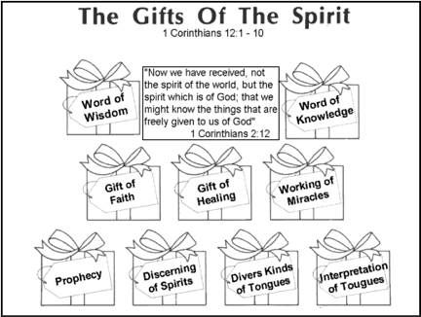

pjsprayerline.blogspot.com.au

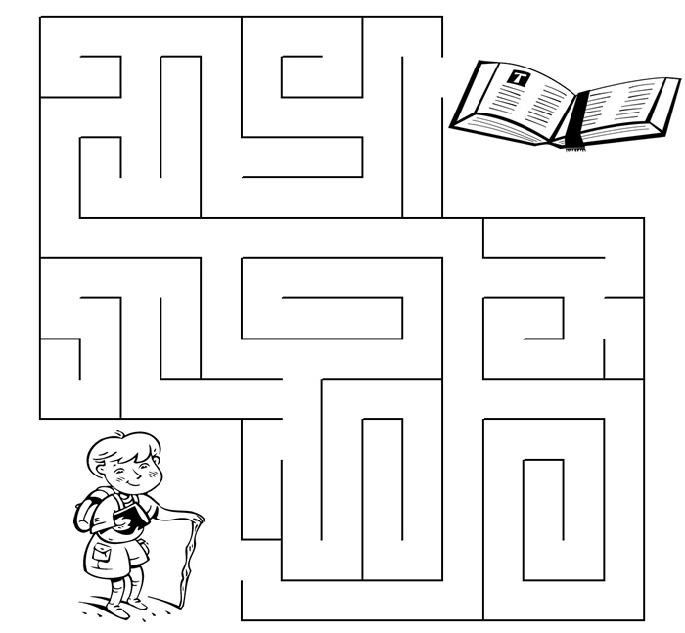Copyright © Sermons 4 Kids, Inc.
All Rights Reserved
Sermons4Kids.com

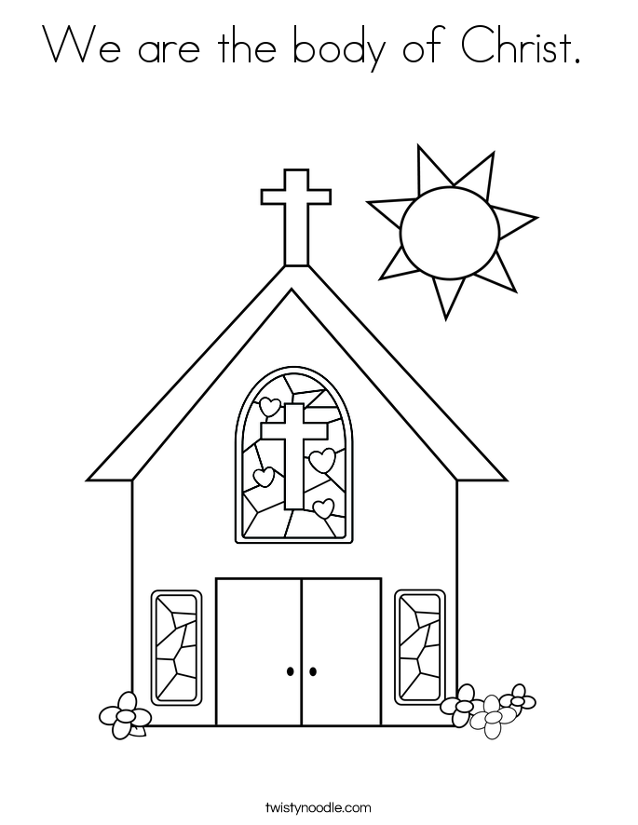

TEEN TALK
Bible Verse: Concerning spiritual gifts, brethren, I would not have you ignorant. Ye know that ye were Gentiles, carried away unto these dumb idols, even as ye were led. Wherefore I give you to understand, that no man speaking by the Spirit of God calleth Jesus accursed: and that no man can say that Jesus is the Lord, but by the Holy Spirit. 1Corinthians 12:1-3

Saint Paul was the author of 1Corininthians mentioned above and many other books of the Bible. Before he became a follower of Jesus he was known to hate and persecute Christians. He was present when St. Stephen, our patron saint was stoned for believing in Jesus. He used to hold Christians as prisoners. He was formerly known as Saul and on the road to Damascus he was made blind after seeing a flash of light before him and hearing the voice of Jesus, asking why Saul was persecuting Jesus’ followers. Jesus told him to get up and go to Damascus to wait for directions on what to do next. When Saul opened his eyes he could not see. The men he was with led him to Damascus. In the meantime Ananias who was a disciple of the Lord had a vision of what he was supposed to do. Ananias was to go to the house where Saul was. Ananias questioned the Lord because he knew that Saul was a persecutor of Christians. The Lord told him that Saul was the chosen instrument to proclaim Jesus’ name to the Gentiles, their kings and the people of Israel. Ananias obeyed the Lord and entered the house where Saul was praying. He placed his hands on Saul and said, “Brother Saul, the Lord-Jesus, who appeared to you on the road as you were coming here—has sent me so that you may see again and be filled with the Holy Spirit.” Immediately something like scales fell off from Saul’s eyes, and he could see again. He got up and was baptized, and after taking some food, he regained his strength.” Acts 9:10-19 That was a miracle that was performed after Jesus’ death and resurrection. Saul became Saint Paul and preached the Gospel of Jesus Christ all over the region of Jerusalem and as far as the country of Spain. Saul believed on the Lord Jesus and the Holy Spirit acted in his life.
At your Confirmation, Bishop John placed his hands on each of you to receive the Holy Spirit. The gifts of the Holy Spirit were then open to you. But at the same time your heart had to be ready as well. Your heart to accept the salvation that Jesus offers to each of us has to be willing to follow Jesus. Read Verse 3 again, “ Wherefore I give you to understand, that no man speaking by the Spirit of God calleth Jesus accursed: and that no man can say that Jesus is the Lord, but by the Holy Spirit.” This verse affirms what I just said. You must believe on the Lord Jesus for the Holy Spirit to work in you. The gifts mentioned in today’s reading, Wisdom, Knowledge, Faith, Healing, Miracles, Prophecy, Discerning of Spirits, Speaking in Tongues and Interpretation of Tongues are just some of the gifts that Saint Paul preached about to Corinth. Others are mentioned in the chart below as well and don’t forget the Fruits of the Spirit shown in the maze below. These gifts and fruits are all there for us if we
BELIEVE!!!!!
THIS VIDEO MAY HELP YOU TO FIGURE OUT WHAT YOUR SPIRITUAL GIFTS ARE:
https://www.youtube.com/watch?v=a6QgkYhEafM&list=TLPQMTQwODIwMjDzw87dSC6AGA&index=3
