Kid’s Corner Week 12

BIBLE VERSE: It was meet that we should make merry, and be glad: for this thy brother was dead, and is alive again; and was lost, and is found. Luke 15: 32

Good morning everyone.
This passage comes at the end of one of my favorite Bible stories. It is actually a parable that Jesus told. Now remember a parable is a simple story that teaches a lesson about doing right and wrong in life. This story is about a son who wants his father to give him his inheritance or money that the son would get after his father dies. But the son wanted the money right then before the father died. For some reason the father gives it to him with no questions asked. The son leaves home, travels all over the world and does everything he wants to do and buys everything he wants to buy. Pretty soon all his money is spent. He doesn’t have anything, not even food to eat. So he gets a job feeding the pig’s at a farm. He is so poor that he eats the pig’s food. Then an idea comes to mind. He thinks about his father’s servants and that even the servants have good bread to eat while he has pig slop. So the son decides to go back home to his father and ask if he could be a servant. So home he goes!! Just as he is coming down the path to tell his father how he had sinned against heaven and wasn’t worthy to be his son, the father sees him and kisses him. The father tells his servants to get the best robe, ring and shoes for his son. He also tells the servants to kill the best calf so they could have a feast and celebrate his son’s return. “He was lost, and is found,” the father said. This story has a happy ending, doesn’t it? This parable about right and wrong is really a story about you and me and the way we sometimes behave. Sometimes you and I make bad choices…..just the way the son did in our story. We wish for things that are not good for us. We don’t want to obey our parents or God. This can be a BIG problem for us. But guess what? I have some good news!! Just like the father in this parable your Father in heaven is ALWAYS willing to take you back. We just have to ask for forgiveness. God loves each and every one of us and wants us to love him!!!

REMEMBER TO READ YOUR BIBLE AND ANGLICAN PRAYERBOOK

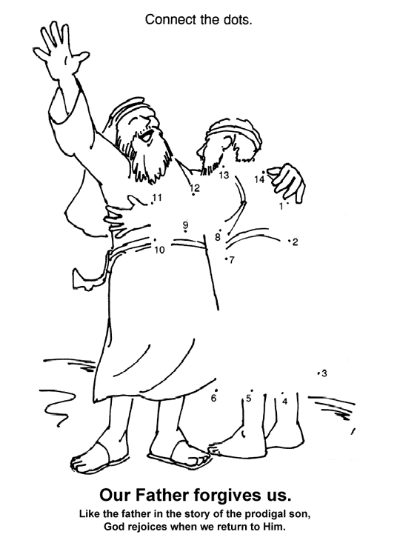
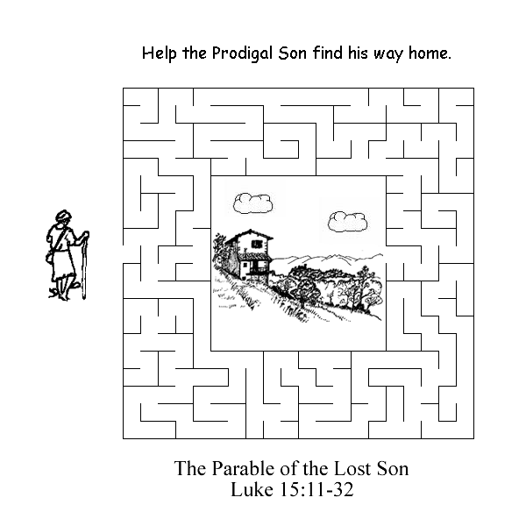

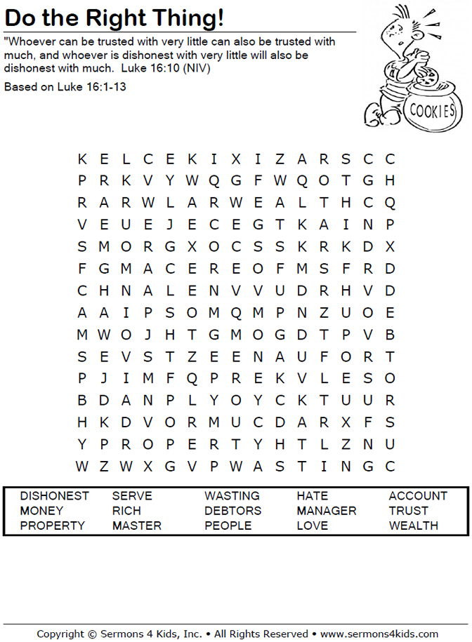

Teen Talk
Bible Verse: And he arose, and came to his father. But when he was yet a great way off, his father saw him, and had compassion, and ran, and fell on his neck, and kissed him.
Like 15:20

Do you remember when you were very little and did something you weren’t supposed to do? Your mom or dad found out and boy were you in trouble. Some of you may have gotten a spanking, or time in your room to think about what you had done or maybe something was taken away from you like your favorite toy or game. I remember punishing my kids, Katie and Johnny but I would always tell them that I forgave them and I would hug and kiss them. This is what a good parent does.

In the parable the Prodigal or Wasteful Son, the son spends all the inheritance money that he would have received after his father’s death. He not only wished his father’s death but then he wasted all of the inheritance money instead of doing something useful with it. He pretty much shamed his father. He was taking care of pigs and eating their slop. He realized what he had done wrong and felt that even his father’s servants were treated better than he was, eating pig slop. He immediately traveled back to his home and felt he wasn’t even worthy to be called his father’s son. But his father was so overjoyed to see his son return that he hugged him, kissed him, threw a party with new clothes and the best food. Wow!!!! He forgave his son. The father was not angry but happy that his son had returned home. Now that is LOVE!!!!

This parable is all about God the Father and us, his children. When we dishonor, disrespect, disobey, abandon and leave God’s presence we behave like the Prodigal Son. Like the father in today’s parable, God the Father gives so many riches and treasures to his children. But when they leave his presence and travel off in their own ways with their own desires, they forget all about honor, respect, dignity and obedience that they owe to him. They forget to be grateful. They forget what he has given to them. Life without God is sin and so man will then waste his inherited gifts of life, knowledge and love on frivolous idols and false gods.

The moral of this parable is that God longs for us to return to his presence. He wants us to find the meaning and what we want to do with our lives WITH HIM. And if we stray away he will always be there with loving outstretched arms to forgive us and take us back into the fold of His eternal kingdom.

This video: Prodigal, an Animation is a really good representation of God’s Love!
Watch the link below:
https://www.youtube.com/watch?v=SZE9syAmKS0

