Kid’s Corner Week 11

Bible Verse: Ye shall know them by their fruits. Do men gather grapes of thorns, or figs of thistles? Even so every good tree bringeth forth good fruit; but a corrupt tree bringeth forth evil fruit. Matthew 7:16-17

Good morning kids,

Hope you are having a wonderful and safe summer. Last summer when we had
Vacation Bible School our theme was Fruits of the Spirit. If some of you remember, the Fruits of the Spirit were:

Love, Joy, Peace, Patience, Kindness, Goodness, Gentleness, Faithfulness and Self Control.

We studied each of these fruits or good qualities. The fruits are the way we ACT when we put our faith in Jesus, ask him to forgive us our sins, and promise to be his followers. The Bible tells us that when we do that, the Holy Spirit fills us with God’s love and produces some “GOOD FRUIT” in our life. Are you patient when you have to wait your turn in line in school or at the store? Do you show love to people that may not be easy to love? The Fruit of the Spirit grows in us just as fruit that we eat grows on trees!!

If we don’t live the way God wants us to live then we will most probably produce “BAD FRUIT.” And you all know what the opposites of the Fruits of the Spirit might be. “Evil Fruit” would get us into trouble and we would not be happy, as we would be disobeying God.

If we live the way God and his son, Jesus want us to live then others will know us by our
“FRUITS.” Our friends and family will know that we are Christ followers and that we obey God.

Dear Lord,

Help us to show your fruits of the spirit in our daily lives. Help us to show love and peace. Help

us to have peace and show patience, kindness and goodness. Lord help us to demonstrate

faithfulness and gentleness and finally help us to have self- control. Please help us to show

others your love by teaching us your ways and growing us as your children. Help us to use the

fruit of the Spirit to show others what your love looks like. In Jesus’ name, Amen

This is the Fruit of the Spirit song that we learned last year:
https://www.youtube.com/watch?v=Rezg4jYFoj0

READ YOUR ANGLICAN PRAYER BOOK AND YOUR BIBLE!!!

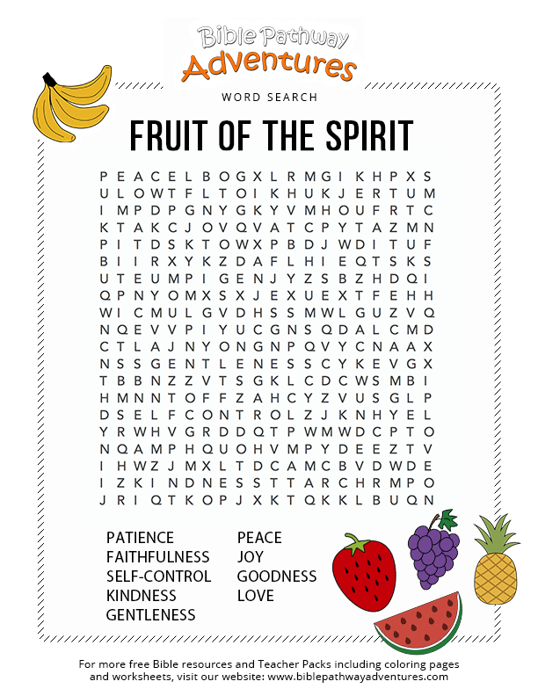

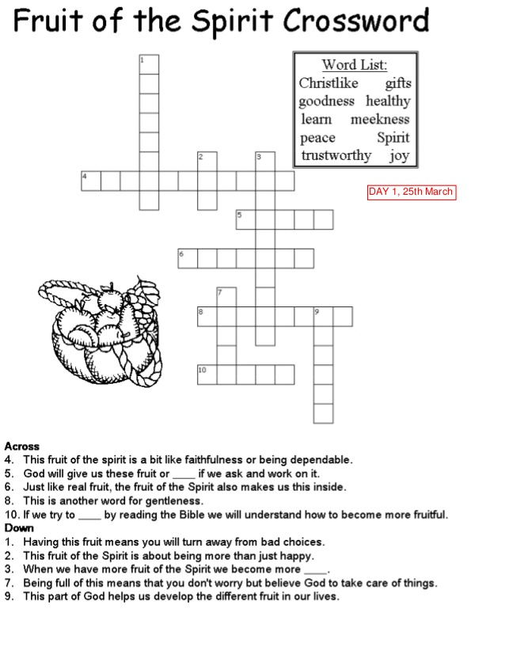

TEEN TIME

Bible Verse: Beware of false prophets, which come to you in sheep’s clothing, but inwardly they are ravening wolves. Ye shall know them by their fruits.

How many of you have known someone who you thought was your friend but they really weren’t? Maybe they got you in trouble and only cared about themselves. This is sort of what the Bible verse is talking about. Someone pretended to be your friend and wore sheep’s clothing like the verse says. They were not exactly exhibiting a fruit of the Spirit, were they?? The fruits of the Spirit are love, joy, peace, patience, kindness, goodness, faithfulness, gentleness and self-control. What fruit would you say that the pretend friend was not exhibiting? Maybe love, goodness, kindness…… These fruits have to be nurtured or grown in our lives so we won’t be the ravening wolf that hurts others. Our purpose on earth is to love God and to show God’s love to others. God gives us the fruits of the Spirit to help us to show others what his love looks like. The fruits are like tools used for this purpose. We can also see this love growing in others and then we know what it’s supposed to look like and how we should behave. God sent his son, Jesus to show his perfect love on this earth and what is was supposed to look like. Jesus taught his disciples how God wanted us to live. All of this information is in the Bible. When we read our Bibles we can see the perfect examples of what our fruit should look like and how we should live for God.

READ YOUR BIBLE, IT IS FRUIT FOR YOUR SOUL!!!!

Watch these youtube Christian song videos:
https://www.youtube.com/watch?v=Ms1uqdX6wXY Start Over-Flame
https://www.youtube.com/watch?v=1kBvpS3z9Qo/ Glorious Day-Passion Concert/Kristian
https://www.youtube.com/watch?v=QM8jQHE5AAk WayMaker- Sinach from Nigeria

