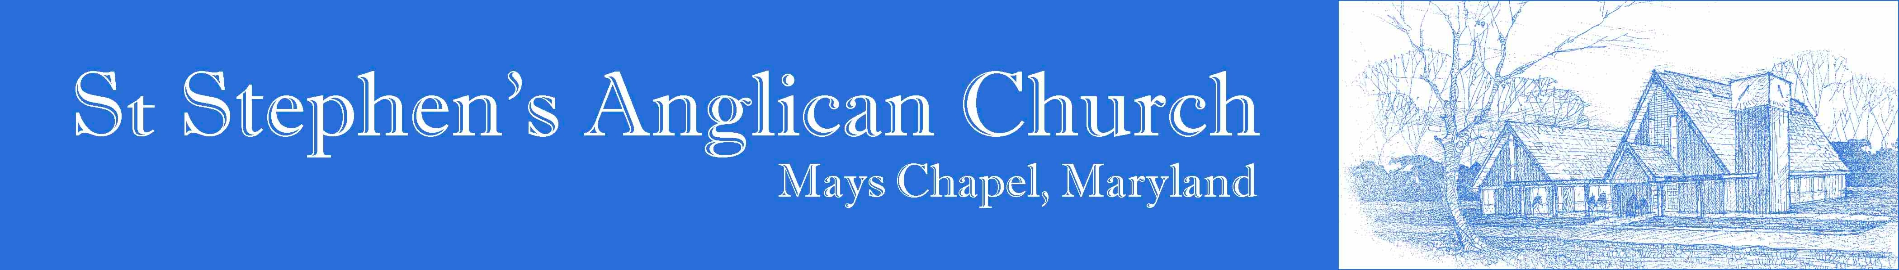
For Safety from a Natural Cataclysm
¶ Written for the imminent convergence of Hurricane Sandy, a nor'easter, an intrusive jet stream, and the first effects of the end of the current b’ak’tun of the Mayan Calendar.

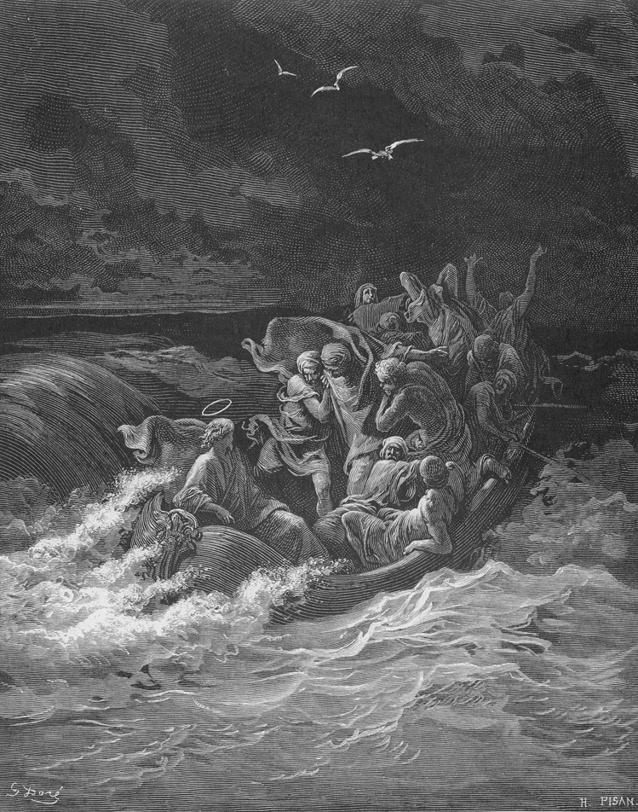
O God, who makest the clouds thy chariot, and who walkest upon the wings of the wind: Preserve us, we beseech thee, from storm and tempest, earthquake and fire. Keep us safe in our homes, and give strength to them that succour those in peril, that we may pass through these tribulations without harm to body or soul; through Jesus Christ our Lord. Amen.
Jesus Stilling the Tempest (Mark iv:39)
by Gustave Doré

