
For a Sports Team

Be mindful of thy servants the NN., O Lord, and watch over their endeavors on the field*; grant them to fight the good fight with courage and strength in adversity, and grace in victory; that their good example and their success may bring credit to our city**, and earn them the approbation of all; through Jesus Christ our Lord. Amen.

* Substitute court, ice, or pitch, as appropriate.
** Substitute school, county, state, or nation, as appropriate.
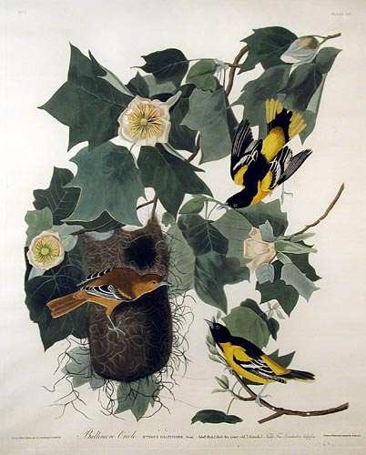
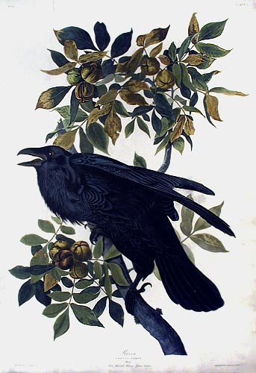
Baltimore Oriole (Plate XII), Raven (Plate CI) from Birds of America by John James Audubon

