FLOWER GUILD NOTES
SCHEDULING AND FLOWER ARRANGEMENTS

Process for flower memorials
Church members can sign up to have their loved ones remembered or acknowledged in a Sunday church bulletin with an altar flower memorial. Those wanting a memorial fill in their name and the wording for the memorial in the log book on the stand next to the water cooler in Cadwalader Hall. When the church bulletins are made up, the wording is inserted into the bulletin for that Sunday. The cost of the memorial is $40 and the check is placed in the Treasurer’s mailbox or given to Bill Hawkins.

Not every Sunday has a memorial signed up.

If you are scheduled to arrange flowers for the next week, it’s a good idea to check the log book on Sunday and see if anyone has signed up for a memorial. If they happen to be at church, you might inquire whether they have a favorite color of flowers. (Annie may have good information for those who regularly give memorials.)

For the scheduler, the log book will indicate with an “X” in that Sunday’s space if there are no flowers for a particular week – such as during Advent or Lent.

Flower schedules
Scheduler should send out the flower schedule for four months at a time, so there will be three schedules during the year:

January – April
May – August
September – December

A reminder e-mail at middle of week is helpful.

Flower guild members
Eileen Cordell
Annie Hawkins
Anne Horner
Carolyn Kerouac
Kim Reynolds
Devon Rock

Supplies
There are a variety of vases available in the tall closets in the auxiliary kitchen. Oasis is in the closet next to the vases. There are some glass containers in the upper cabinets. We rarely use glass containers for the altar.

Bill Hawkins ordered the oasis by the case. When one case is about half used, notify Bill to order within the next few weeks.
Pruners and scissors are in the drawer next to the vase closet.

Purchasing flowers
Flowers can be purchased at Sam’s Club with a church card. If you have a card, or have borrowed one from another card holder, be sure to press “tax exempt” when prompted from the card machine at checkout. Note “flowers” on the receipt and leave in Bill’s mailbox.

Trader Joe’s and Food Lion also have good flower prices.

Pennock’s Floral on Coldspring Lane has a church account on file. They are only open on Saturday from 6:30 – 9:30 AM. Weekdays until 5:00 PM. This is a good option when for a large amount of flowers.

If you are using your own credit card or cash, keep the receipt and give to Bill Hawkins to request reimbursement or charge against your church pledge

The average spent on weekly flower purchases is about $30.

Dark purple flowers do not show up well from a distance if that is the only color, however they look good if paired with white.

Altar flowers
Altar flowers can be changed out on Friday or Saturday. There is a Friday noon service and a Saturday 5:00 service, so work around those schedules.

The best way to view flowers as they are being arranged is to bring the entire pedestal to the parish hall to arrange flowers. Take out old flowers, keep what is still usable, throw others in trash can. Often greens can be used for another week.

Depending on the flowers you have purchased and their best arrangement, choose a container from the closet or re-use last week’s containers.

Before beginning, turn on church lights from electrical closet at back of church so that you can view the flowers when completed.

Next, soak the oasis while you are getting your flowers ready to arrange. Put at least two oasis bars in the white dish pan in the kitchen sink, and fill with water. Carry the pan with water and oasis to the area where you will be arranging. When you cut your oasis to fit the bowl, if there is still dry oasis in the middle, soak a little more.

Cut the large bar of oasis to fit the bowl and push down for a tit fit. Cut smaller pieces on an angle. Fill the entire bowl with wet oasis, pushing down as needed. Cut off top with knife to level of bowl.

Remove rubber bands/paper from flowers and either place them in a black floral container (located in utility storage room) or lay them out on the table so you know how many you have of each.

Goal is to create mirror images from one bowl to the other.

Begin with one tall fern or other greenery at the back.
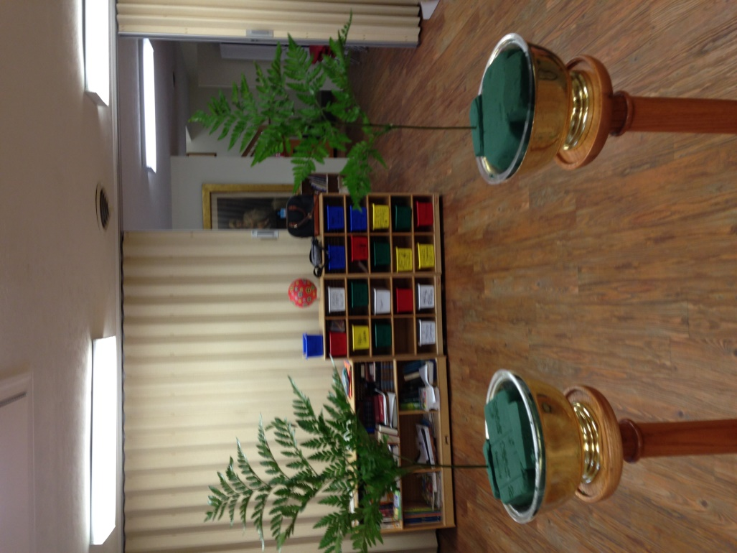

Fill in the back of the vases with additional greens.
(Don’t worry about the front – that will be filled in later.)

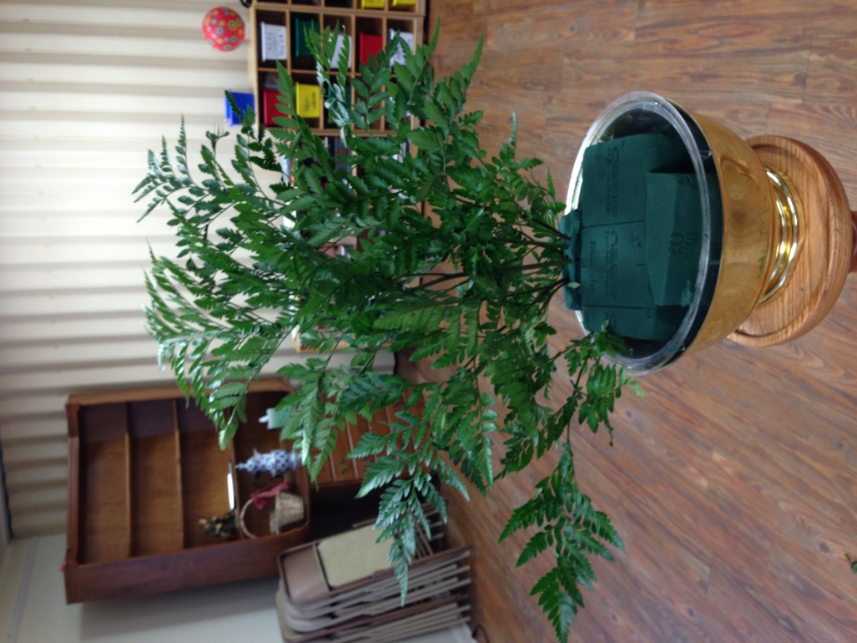

Repeat each step with the other vase.
Fill in entire back and sides with greens, leaving front to do at the end.
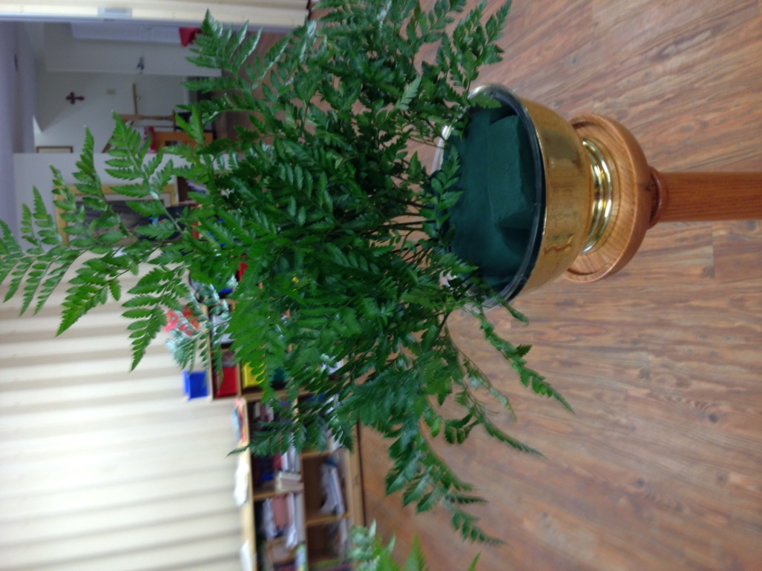

Begin filling in flowers. Start with one tall flower at the back. Always cut flowers before placing in oasis so that they can soak up water more easily. Cut flowers at an angle. If there are nubs on flowers, cut above the nub.

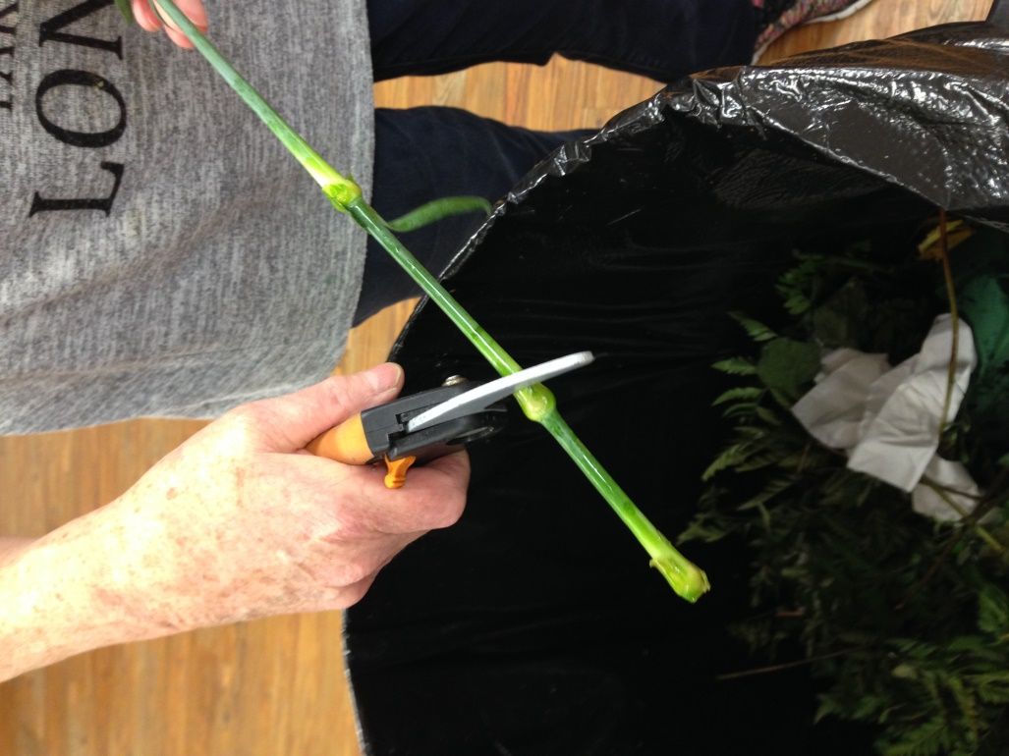

Make a pyramid with next flowers, always placing an UNEVEN number of flowers in vase – 5, 7, 9, etc. This provides symmetry to the arrangement.
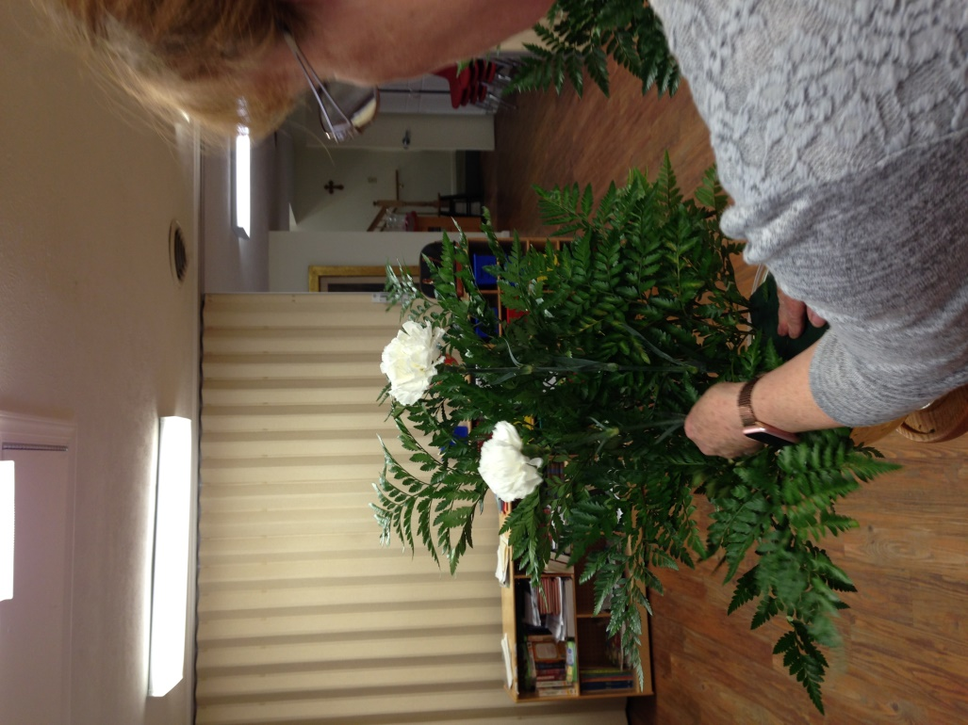

Continue adding flowers to create a pyramid effect.

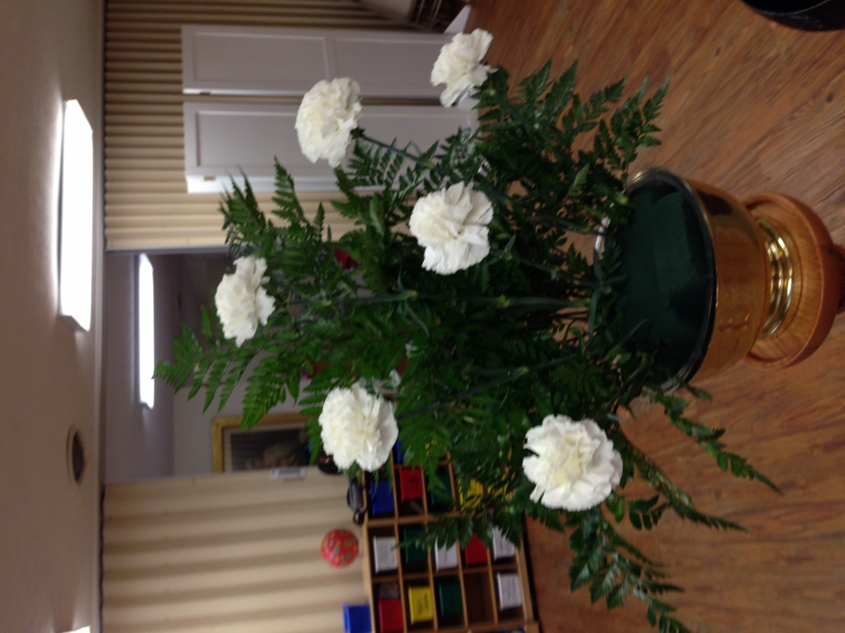

To ensure best mirror image, cut two flowers together – then stems will be the same length.
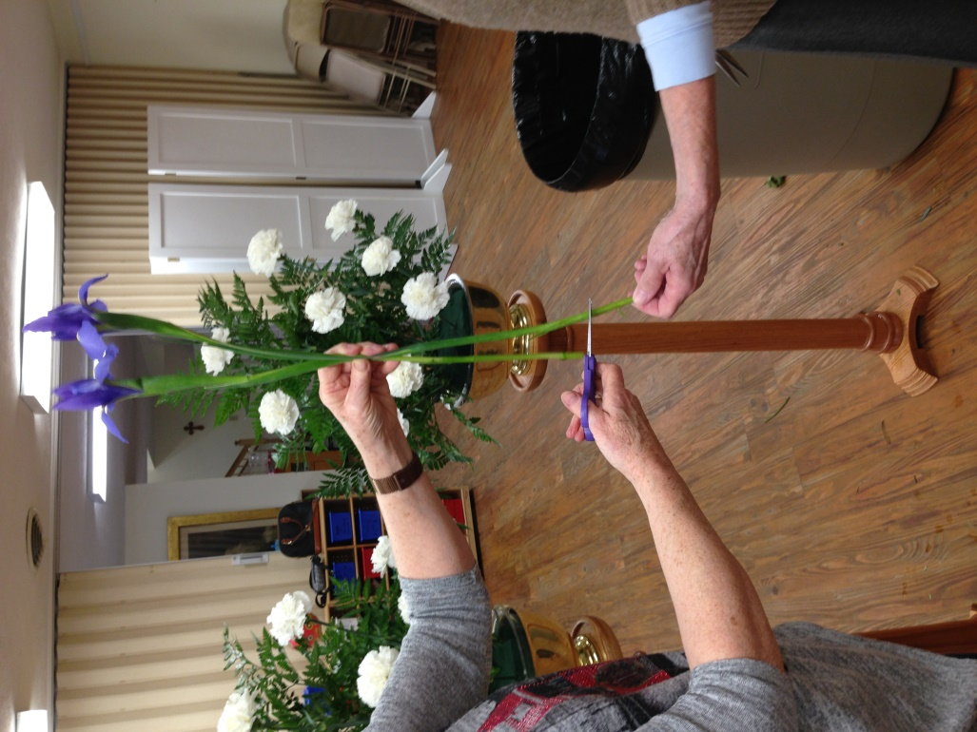

When all of one flower has been placed, begin placing additional flowers (when two varieties are used.)

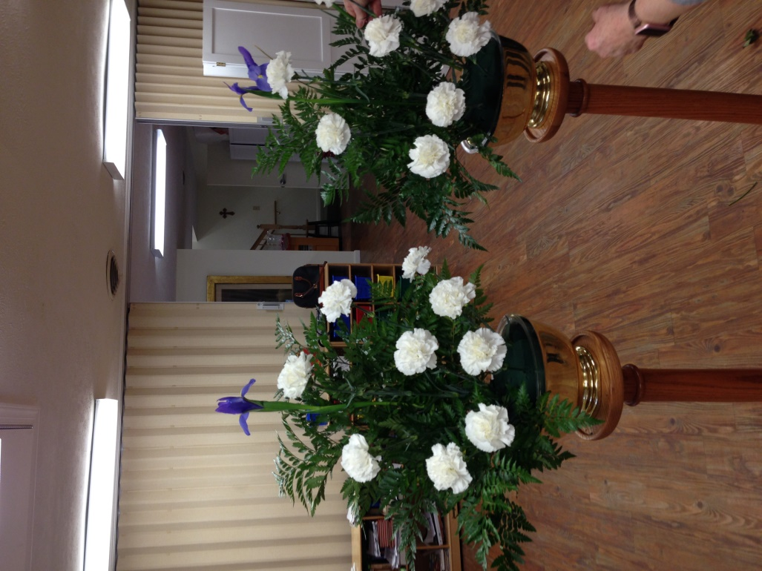

Continue placing additional flowers until arrangement looks complete.
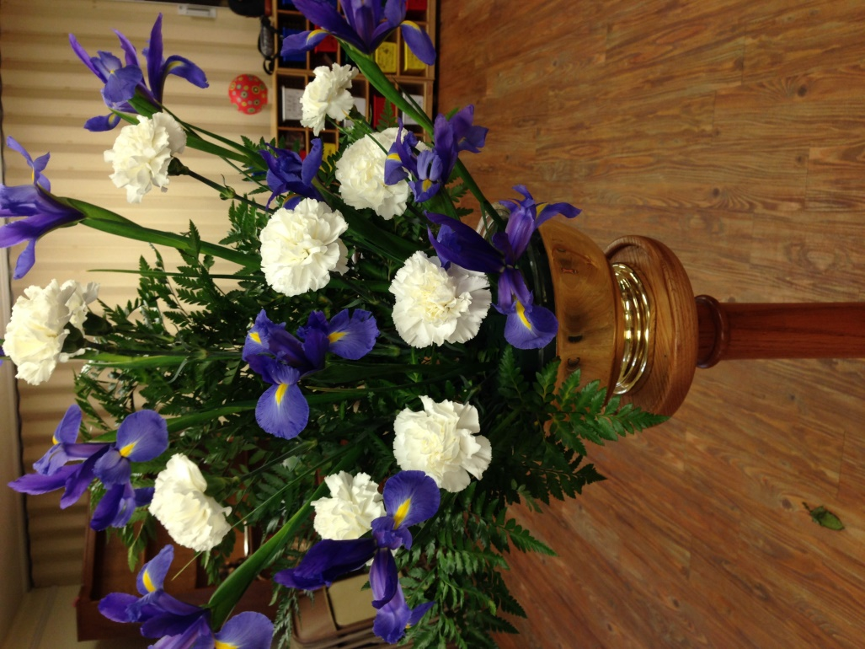

Place short stems to place flowers in front.

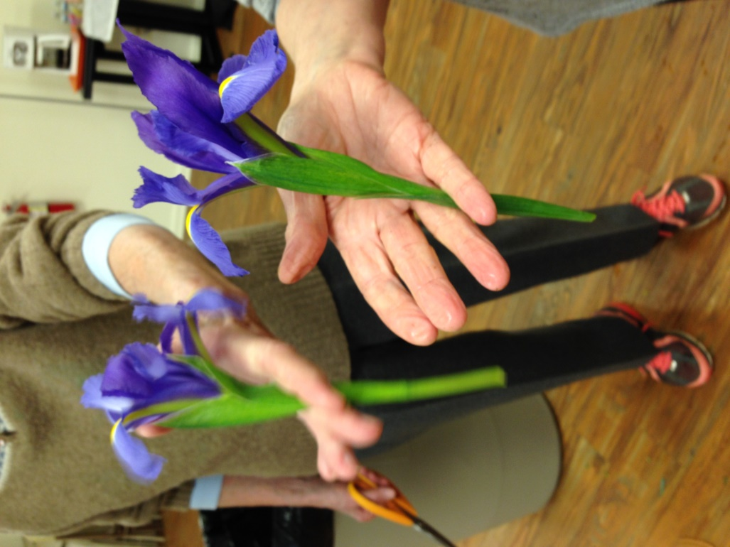

Cut greens short and place in front part of oasis so they hang down over the edge of the vase.
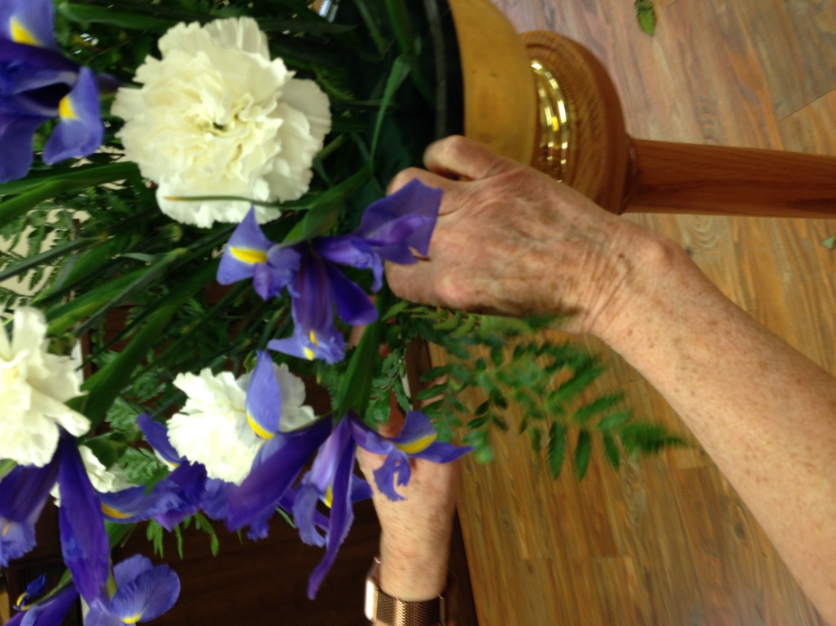

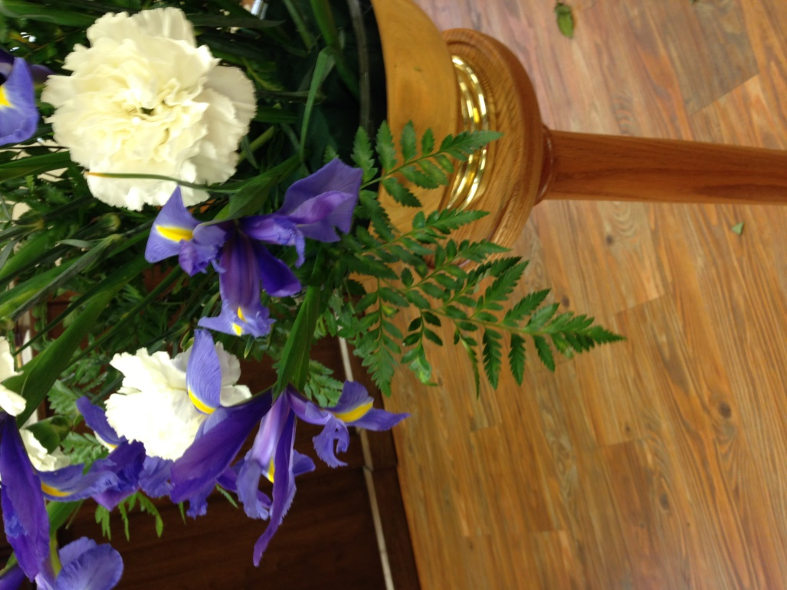

Examine arrangement and add any additional flowers to fill out, if available.

The finished product!
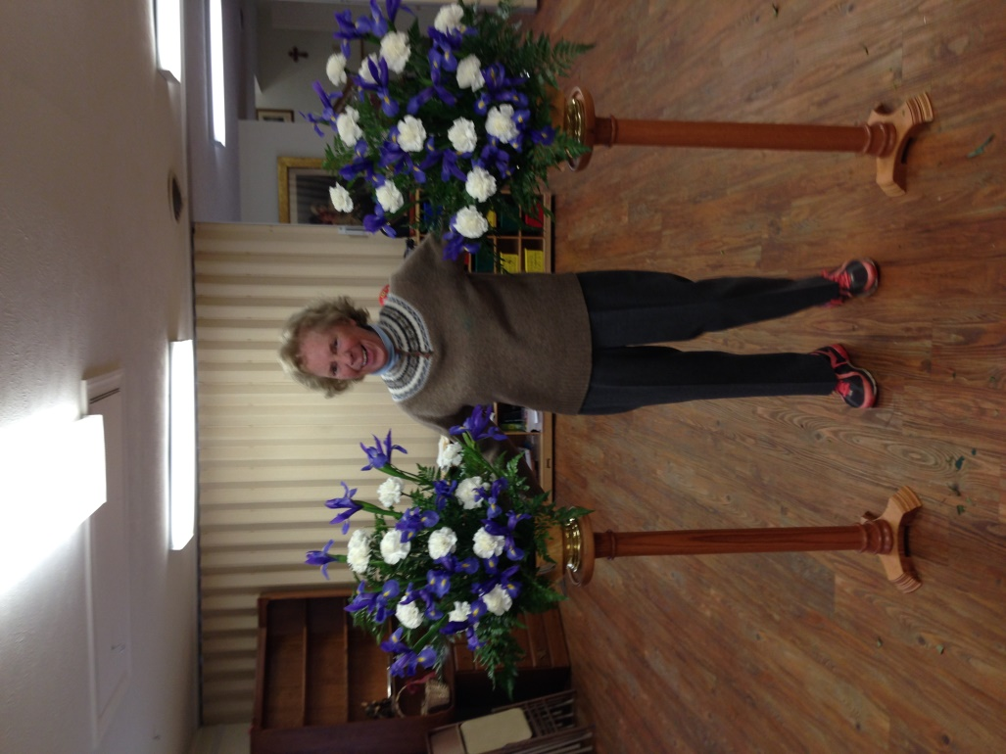

Carry vases and altar stands to each side of the altar, and then add additional water.
Walk to back of church to view arrangements.

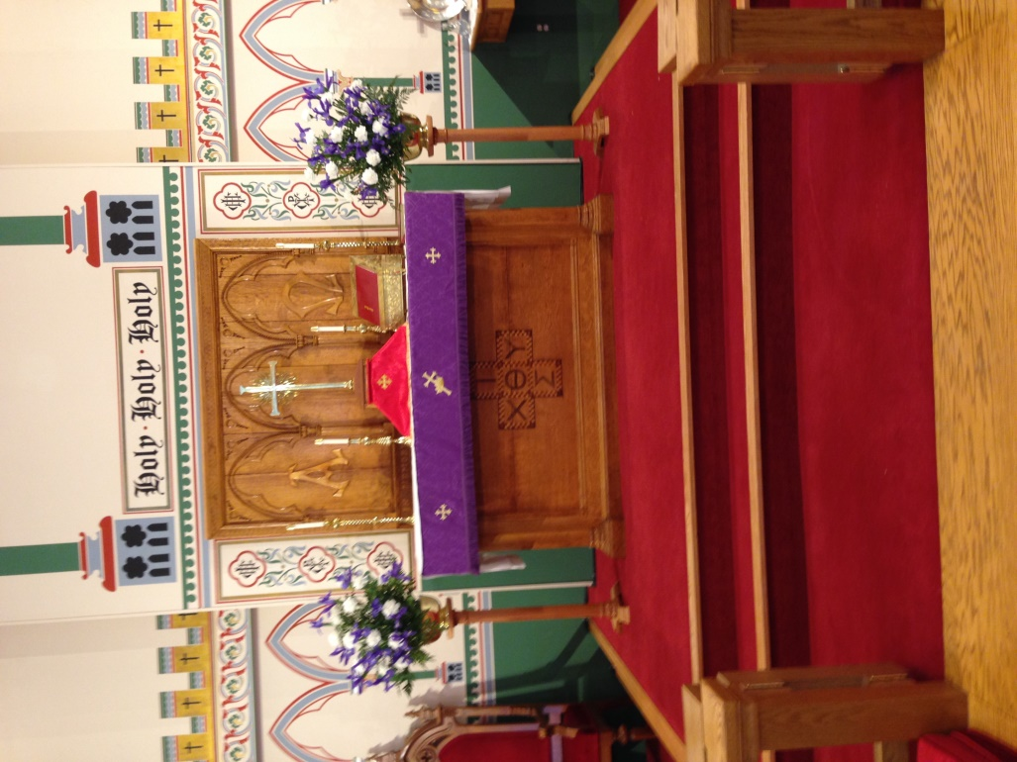

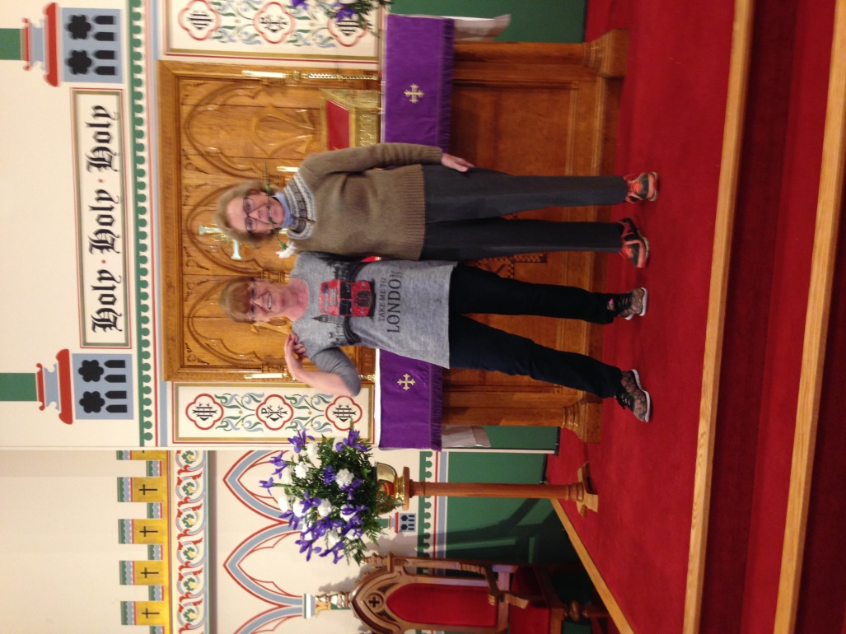

Coffee table flowers
Make an arrangement for the coffee table from last week’s flowers. There are usually enough “still alive” to make a second small arrangement. Throw away last week’s coffee table arrangement.

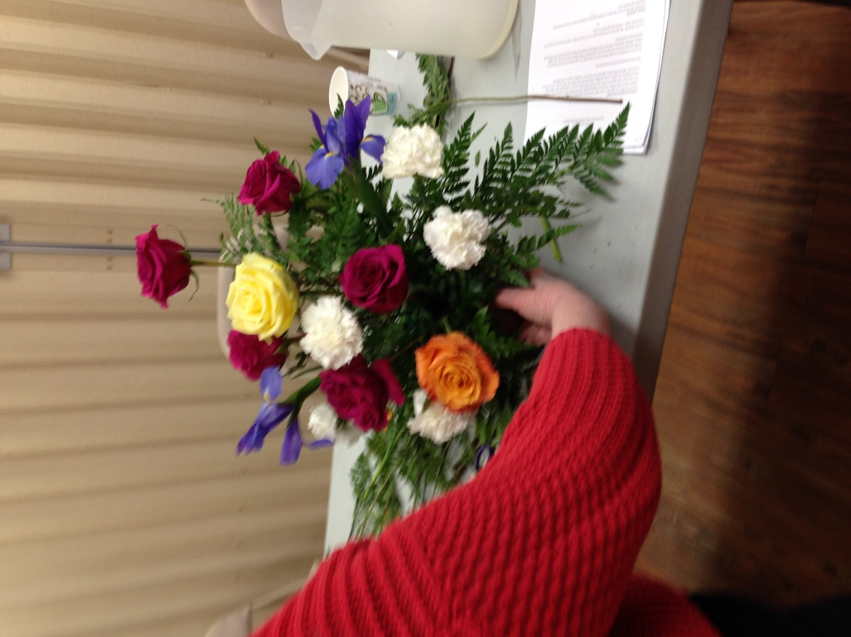

Children’s altar
Take a few of old or new flowers and put them in a bud vase for the children’s altar.
Throw away last week’s bud vase flowers.
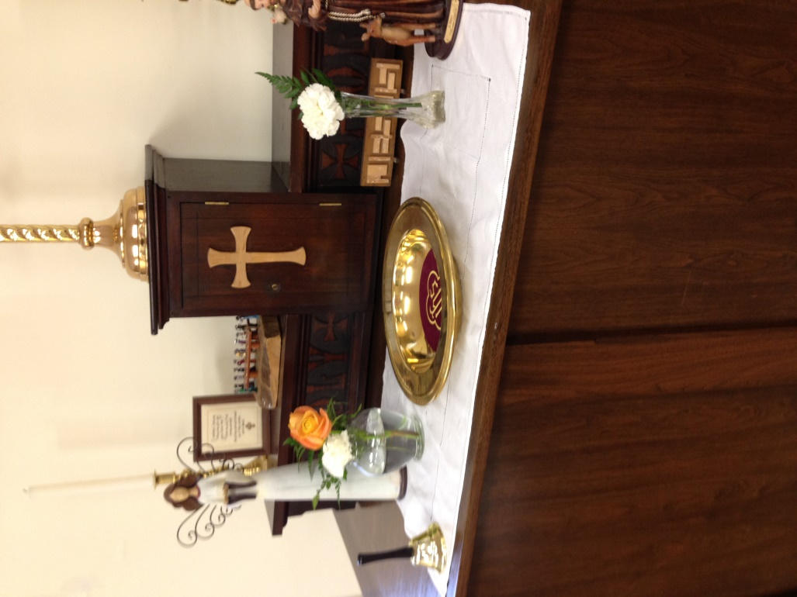

TIP for carnations:
Before placing in arrangement, gently pull flower petals apart to create a fuller flower.

